12th IAA/AIDAA Symposium on Future Space Exploration
09-11 June 2025, Torino, Italy

Technology

PERFORMANCE AND SENSITIVITY ANALYSIS
OF SUNDIVER SOLAR SAIL TRAJECTORIES

Perepukhov D. ⁽¹⁾, Diugaeva Iu. ⁽²⁾

⁽¹⁾ Keldysh Institute of Applied Mathematics
Miusskaya Pl. 4, Moscow, 125047, Russia
dperepukhov@keldysh.ru

⁽²⁾ Moscow Institute of Physics and Technology
Institutsky lane 9, Dolgoprudny, 141700, Russia
diugaeva.iud@phystech.edu

Keywords: solar sailing, sundiver trajectories, performance analysis, sensitivity analysis

ABSTRACT

A Sundiver trajectory is a type of fast solar sailing trajectory where a small solar sailing spacecraft performs a close solar flyby in order to enter a high-energy hyperbolic trajectory. With the increasing interest towards the exploration of the interstellar medium and the Solar system’s distant regions, the Sundiver trajectories are becoming increasingly relevant. As an example, the current concept of the mission to the solar gravitational lens focus implies sending a group of small solar sailing spacecraft more than 550 AU away from the Sun. To reach such a remote region, it is proposed to perform the Sundiver maneuver so as to provide the spacecraft with a hyperbolic excess velocities of up to 25 AU/year. An illustration of the proposed trajectory is shown in Fig. 1.
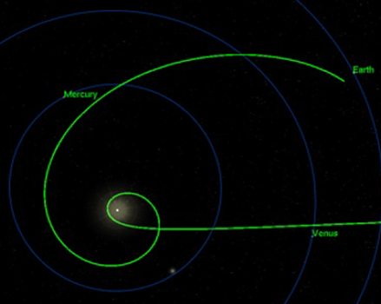
Figure 1. Illustration of a Sundiver trajectory.

This research is aimed at studying characteristics of the Sundiver trajectories. In particular, the following questions are to be answered: what hyperbolic excess velocity can be achieved with the Sundiver maneuver and how sensitive the maneuver is to the control errors. To answer these questions, a novel approach based on the backward in time propagation is proposed. This approach makes it possible to study only the sundiving part, decoupling it from the segment of departing from the Earth’s heliocentric orbit, which is usually considered in the literature.

Using the proposed approach and the locally-optimal control laws for a flat non-perfect solar sail, multiple Sundiver trajectories were calculated for various values of the solar sail’s characteristic acceleration, the target hyperbolic excess velocity, and the target hyperbola’s pericenter distance. As a result, a database of sundiving arcs was obtained. It was used to plot a graph that represents how the attainable hyperbolic excess velocity depends on the other two mentioned parameters. Some trajectories from the database were also propagated forward in time with specially introduced control errors. These simulation results were used to draw conclusions on how imprecisions in the sail control affect Sundiver trajectories.

