INVESTIGATING THE POTENTIALITY OF LIGHT SPECTRUM IN SPACE FARMING: A STRAWBERRY CASE STUDY

Nicolò Grasso⁽¹⁾, Franco Lombardi⁽²⁾, Bruno Mezzetti ⁽³⁾
⁽¹⁾ Politecnico di Torino, Dipartimento di Ingegneria Gestionale e della Produzione, Corso Duca degli Abruzzi, 24, Torino (TO), nicolo.grasso@polito.it
⁽²⁾ Politecnico di Torino, Dipartimento di Ingegneria Gestionale e della Produzione, Corso Duca degli Abruzzi, 24, Torino (TO), franco.lombardi@polito.it
⁽³⁾ Dipartimento di Scienze Agrarie, Alimentari e Ambientali, Università Politecnica delle Marche, Via Ranieri 65, 60131 Ancona (AN), b.mezzetti@staff.univpm.it

Keywords: Space Farming, Strawberries, Light Spectrum, Space Food, Astronaut Diet
ABSTRACT
Food plays a crucial role in human space exploration. A balanced and nutritious diet for astronauts is essential for maintaining their physical and mental health and performance during space missions. However, bringing food to space presents several challenges related to food quality and variousness, as well as the high cost and logistical difficulties of transporting supplies from Earth.
Indoor farming (IF) is a technique that involves growing crops using aeroponic or hydroponic nutrition, artificial lighting, and climate-controlled environments. While this technology has already been implemented on Earth, it has also sparked interest in its potential for space exploration, especially for the Moon or Mars permanent bases. IF is essential for ensuring the human capability of steadily colonizing external planets since it can mitigate many of the needs of earth-coming supplies and fresh, calorie and vitamin-rich food.
Space farming (SF), meaning IF for space applications, presents several challenges on plant physiology and technological levels. For instance, it faces crop production in diverse scenarios and diverse needs, such as the importance of fastening crop production while ensuring high quality food and using a minimum amount of resources.
Light radiation plays a pivotal role in this complex scenario since it can affect plant development at different levels. As well established, crops maximize energy uptake from photons in the red and blue parts of the visible spectrum. However, other radiations are important in driving plant metabolism.
Here, we propose to examine strawberries' responses to various spectra, assessing their effect on growth, flowering time, fruit productivity and secondary metabolism induction.
Our finding reveals that adequate control of the light spectrum makes it possible to time the flowering time and induce strawberries to accumulate important molecules for human health.
These results provide a solid basis for SF, as they can be used to minimize energy costs per total fruit production and regulate the time required for production. In addition, the stimulation of secondary metabolism can lead to the accumulation of substances important for the human diet, ultimately facilitating living in extraterrestrial environments.
1 - INTRODUCTION
Since the mid-20th century, mankind's attitude to exploration has taken us beyond our planet's borders. In 1957, the first satellite was launched [1], then only four years later, Yuri Gagarin [2] was the first human to leave our planet, followed by the crew of Apollo 11, who reached the Moon in 1961 [3]. Driven by different forces, the technology has grown rapidly to support all the steps from the 1957 launch to today's missions. Although generally successful, all these missions are hampered by an intrinsic constraint of this kind of exploration: all the necessary goods for space exploration, including oxygen, must be brought from Earth for proper propulsion combustion as well as for human crews [4]. This constraint is particularly severe for consumable goods, such as propellent and food. Moreover, the distance on which the mission occurs is a consistent parameter. Although it is relatively easy to supply any consumables to the International Space Station (ISS) [5], which orbits close to Earth, this is no longer true for deep-space missions, such as establishing a permanent settlement on the Moon or Mars [6].
In this future mission, it will be necessary to rely on on-site resources for water, propellant, oxygen, and food. The average food consumption for an astronaut is considered to be over 800 kg per year (including packages) [7], which translates to a shipping cost that varies from $2.4M (to the ISS) to $14M (to Mars) per person per year [8].
Given the economic and logistical impossibility of shipping food from Earth, space bases must grow their own food in situ to survive.
Indoor farming (IF) refers to the cultivation of crops in controlled environments using soilless systems (such as aeroponics or hydroponics) rather than soil-based cultivations, supplemented with artificial lighting and precise climate regulation. IF has the advantage of being capable of providing fresh, nutritious food rich in calories and essential vitamins all year round, independently from external climatic conditions [9]. While this approach is already well-established on Earth, its potential applications for space exploration are still being researched and analyzed.
When adapted for extraterrestrial environments, IF becomes space farming (SF) [10]. SF offers the possibility for astronauts on extraterrestrial bodies to grow their food, but it faces several challenges. As it is for IF on Earth, SF needs to provide a reliable autonomous system capable of maintaining specific environmental conditions to maximize crop productivity or conserve resources (water, energy, and nutrients) [11]. Unlikely IF, SF also needs to account for precise production timing since crops need to be ready in a predictable time in order to feed crew members with the right amount of nutrients at the right time, avoiding overproduction (which could lead to food wasting) or underproduction (that could lead to crew starving). For long-lasting deep-space missions, crop production must be predictable and programmable, allowing crews to anticipate and synchronize harvests with consumption patterns.
SF requires precise environmental regulation, including the modulation of factors such as light spectrum, temperature, humidity, and nutrient delivery [12].

One particularly promising approach to controlling plant development is the targeted use of the light spectrum to influence key physiological processes. Spectral tuning has been shown to impact flowering time, fruit set, and other physiological behaviours [13] [14] [15]. By adjusting light quality and intensity, it becomes possible to tune flowering and adjust fruit development [16]. Such control mechanisms are crucial in ensuring that food is available precisely when needed.
Although several studies have been conducted on lighting systems for IF on Earth [17] [18] [19], SF requires a different approach. As in the early 2000s, studies focused mainly on the photoperiod and photon density [20] or the technological aspects of lighting in space [21] [22] several aspects still needed to be addressed. Indeed, more recently, [23] suggested that different lighting recipes could affect the growth and morphology of lettuce plants. Meanwhile, [24] tested the different physiological performance of irradiated seeds under various light spectra, and [25] studied the effect of far-red lighting in combination with carbon fertilization.
Although promising, these examples fall short of addressing a crucial aspect of space missions. As we reported [26], when considering the space application of plant growth, it is pivotal to rely on robust indicators that help address space-specific needs, such as not only the produced biomass or nutritive content of a crop but also the time needed to produce that resource. Therefore, here, we introduce the use of a specific KPI, able to measure the number of calories (or of nutrients or other important molecules for the human diet by easily changing its parameters), named calorie delivery efficiency (CDE), measured as kcal*kW⁻¹*day⁻¹, which implicitly considers the electrical consumption and the days to produce crops.
The paper is organized as follows. Section 2 provides a detailed description of the aeroponic chamber setup and the experimental activity. Section 3 focuses on the achieved results, using both classical indicators and our indicator. Section 4 presents a discussion on the advantages and benefits of our experimental design, while concluding the paper.
2 - MATERIALS AND METHODS
2.1 GROWING FACILITY
Aeroponic systems for strawberry cultivation were placed inside a growth tent (Mammthtent, NL) measuring 1.5 meters in width, 4 meters in length, and 2 meters in height. The tent was equipped with a ventilation system and a heating/cooling system (Solea, booster heater, and De Longhi Pinguino), as well as sensors to monitor CO₂ concentration (Atlas Scientific, NY, USA), temperature, and humidity (Adafruit Industries, NY, USA). Moreover, it hosted several strawberry-growing systems. Each growing system consisted of a tank for the nutrient solution, serving as a reservoir for the irrigation system (Newa, Micro-Jet pump, IT), a growing surface where crops were hosted (Nutriculture, UK), and a lighting system (Prisma SRL, IT). Moreover, each growing system was equipped with EC and pH sensors (Atlas Scientific, NY, USA), coupled with four peristaltic pumps (Atlas Scientific, NY, USA) to maintain the irrigation solution at a given pH value and nutrient concentration, as well as a mixer that continually recirculated the solution. Each growing system was capable of hosting up to 16 plants (see Figure 1).
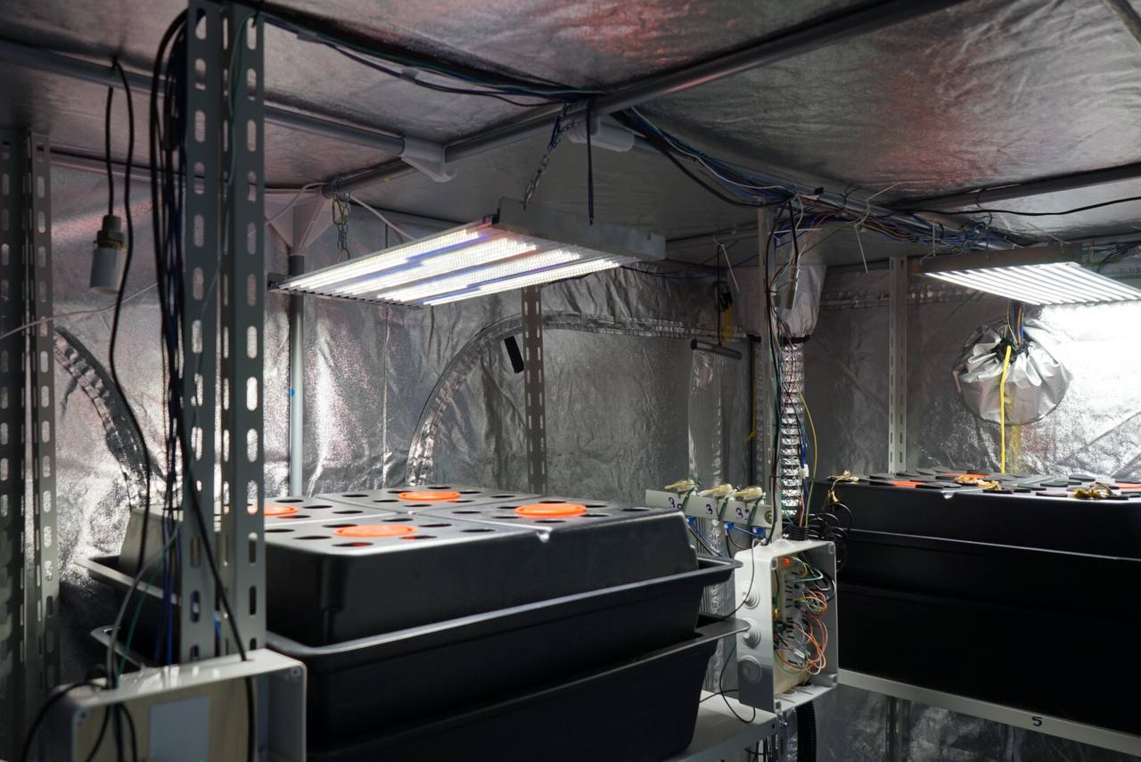
A Raspberry Pi 4 model B was used as a microcontroller. It collected data from the sensors and consequently regulated all the actuators in the tent, maintaining the desired climatic conditions. Light conditions were fixed since each growing system had its custom-designed lamp. MyCodo [27], open-source software, was used for data collection, logic control, and data transmission through the MQTT protocol [28]. A more detailed description of our implementation is provided here [11].
Figure 1: An overview of the growing facility, two growing systems can be observed, with different light spectrum provided to the plants.
2.2 PLANT GROWING CONDITIONS
The Polytechnic University of Marche kindly provided two different genotypes of strawberry plants, “18,13,52” (genotype 1) and “12,13,58” (genotype 2) . Twenty-five-day-old plants were carefully removed from their spot, and the ground was gently removed from the roots to place them into the aeroponic system. Clay was used as a substrate to hold crops in position. For each environmental factor, a range was defined according to the literature, as reported in Table 1.
Besides the environmental condition, the other system-specific parameters were defined as follows:
- the irrigation cycle operated for two minutes every 15 minutes [29],
- the ventilation system was activated for 5 minutes every 10 minutes,
- the used nutrient solution was the commercially available Mills solution: NH4 0.3%, NO3 3.2%, K2O 4.3%, CaO 5.1%, Fe 0.042%, P2O5 4.3%, MgO 1.1%, SO3 2.2%, B 0.0045%, Cu 0.0025%, Mn 0.02%, Mo 0.001%, Zn 0.01%.
Strawberry plants were divided into two batches; the first one (control) received only white light, whereas the second one (treated) received white light plus far-red light. The control lamp was composed of 10 LED bars 60 cm long, while the treatment lamp was composed of 10 white bars plus 2 far-red bars, all 60cm long. Both control and treated plants were placed 40 cm below lamps, in order to obtain the desired light intensity.
Table 1 - Summary of tested parameters for strawberries
Parameter | Value | Reference
Temperature | 18°C – 24°C (±1°C) | [30] [31] [32]
Humidity | 65% (±10%) | [33] [34]
Light intensity | 300 – 350 µmol/m²s | [31] [35] [36] [37]
CO₂ Concentration | 420 – 450 ppm | NA
Photoperiod | 16/8 h | [37] [38]
pH | 5.8 – 6.5 | [39] [40] [41] [42]
EC (growth phase) | 1200 µS/cm | [39] [43] [36] [41]
EC (flowering phase) | 1400 µS/cm | [41] [29]
2.3 EXPERIMENTAL DESIGN and INDICATOR COLLECTION
As discussed in sections 2.1 and 2.2, two genotypes were tested for the far-red effect on flowering time and fruit set time. Eight plants per genotype were placed inside the previously described growing system for approximately 3 months. Each growing system was filled with 35 litres of nutrient solution at the defined levels of electrical conductivity (EC) and pH. The strawberry growth observation period started on September 16, 2024, and ended on February 14, 2025. The water level was manually measured weekly and refilled to the original value to prevent nutrient concentration, whereas nutrient refill was autonomously provided by means of peristaltic pumps. Moreover, sprouts and dry leaves were periodically removed.
To properly assess the results of the treatment, we evaluated several indicators from both the productivity dimension and the quality dimension; then, we computed the acquired data to derive the new indicator CDE.
As for the productivity indicators, we measured the flowering time (in terms of the number of days after transplant), the total number of flowers, the number of days to first fruit (both as days after transplant and days after flowering), and the fruit fresh weight (using a Radwag PS1000.R2 lab-grade scale). For the number of days to the first fruit, we consider the first mature fruit per plant (see Figure 2) based on colorimetric operator perception. For the fruit weight, 10 fruits per plant were randomly chosen
Instead, for the quality dimension, we assessed the brix degree and, therefore, the sugar content. To do so, an average of 4 to 5 fruits were collected per treatment and then homogenised and filtered (Whatman grade 4). A portion of the filtered liquid was used to determine the Brix degree using a commercial digital refractometer (DBR55, digital refractometer).
According to [44], we used the following formula to estimate the total sugar content:
$$Total sugar content (\frac{g}{ml})=\frac{0.873*°Brix-0.420}{100}$$
Then, we assumed the equivalent of 3.75 kcal per gram of sugar present in the fruits [45]. To complete the formula, we assumed 60% of flowering to settle fruit [46] and the strawberry to be composed of around 92% of water and soluble molecules [47].
Finally, we constructed our indicator (CDE) by computing the total calories data (considering the average number of flowers and fruit per plant, as well as their weight and sugar content), with the production time and energy consumed. CDE was evaluated per system, considering the production of 16 plants per system and the energy consumption was estimated according to our previous work [11]. CDE was then computed with the following formula:

$$CDE=\frac{Total sugar content*0.92*n° of flowers*0.6*fruit weight*3.75}{day to first fruit*energy consumption}*16$$
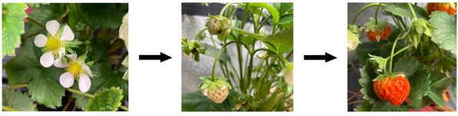Figure 2: Flowers and fruits of aeroponically grown strawberries.
3 - RESULTS
In this work, two lighting conditions were compared: the first one (named control) used white light on strawberry sprouts, whereas the latter (treatment) added far-red radiation to the white light on the same crop. According to the literature, the treatment aims to enhance strawberry production by promoting faster flowering.
This section presents a comparative analysis of these two lighting regimes based on diverse indicators, covering both the productivity dimension and the quality one.
3.1 FLOWERING TIME
Plants grown under the combined white and far-red light system (treatment) initiated flowering 37 days after transplantation. In contrast, the first flower in the control system appeared 36 days later, marking a total of 73 days from transplantation to the onset of flowering. As reported in Table 2, the flowering phase occurred over several weeks, from the first plant in each system and genotype to flower. Overall, treated plants appeared to flower a month earlier than control plants, suggesting the far-red radiation was actually capable of accelerating the flowering phase.
The importance of the genotype is also highlighted in Table 2 since genotype 2 flowered earlier in control plants but later in treated plants.
Table 2: Average number of days to first flower
 | Control (days) | Treatment (days)
Genotype 1 | 87±5 | 50±6
Genotype 2 | 82±5 | 58±7

3.2 NUMBER OF FLOWERS
Following the onset of flowering, plants began producing flowers in varying quantities and at different times.
Due to the delayed initiation of flowering in the control system, plants in this group accumulated a lower total number of flowers by the end of the observation period compared to those in the treated group. Nonetheless, the difference between the two groups was relatively modest - approximately 10 flowers per plant.
As illustrated in Graph 1, treated plants exhibited a steady increase in flower production, with an average weekly growth of nearly 30%, allowing the most productive plant to approach 100 flowers within 65 days. Conversely, control plants exhibited a higher relative growth rate in terms of flower number, ranging from 40% to 50% per week. As a result, even with the delayed onset of flowering, the most prolific control plant reached 79 flowers in just 42 days. This finding is important because it appears that, on the one hand, the far-red radiation actually speeds up the flowering time. However, on the other hand, plants might not be mature enough, and therefore, they produce a smaller number of flowers per week.
As for the flowering time, the genotype also seems to respond differently to the treatment. Indeed, genotype 1 shows a higher number of flowers in treated plants compared to genotype 2, whereas the situation is the opposite in control plants.
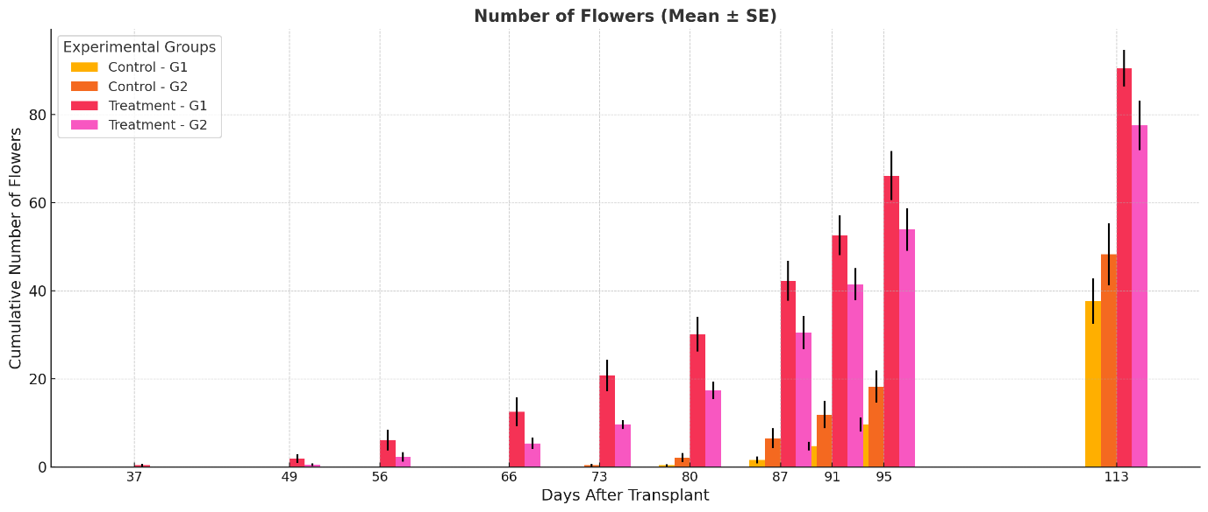
Graph 1: Average cumulative number of flowers per plant during a four-month long observation period.
3.3 NUMBER OF DAYS TO FIRST FRUIT
While far-red light significantly influences the onset of flowering, its effect on fruit emergence appears to follow a different dynamic. As suggested in Section 3.2, treated plants may be less mature than control ones, reflecting this weakness in delaying fruit emergence.
As shown in Table 3, fruit formation occurred earlier in the treated plants, in terms of days after transplant (dat). However, the result differs when flowering initiation is considered the starting point (daf). Indeed, control plants exhibited a shorter time to fruit sets, around 40 days, compared to treated ones, where the fruit sets took over 60 days. Consequently, the time interval between the first fruit appearance among the two experiments is considerably shorter than the one observed for the flowering time.
Table 3: Number of days to first fruit, considering both the transplant (dat) and the day to first flower (daf) as starting points.
 | Control  (days) |  | Treatment  (days)
 | dat | daf | dat | daf
Genotype 1 | 130±10 | 43±7 | 114±13 | 63±8
Genotype 2 | 121±10 | 39±6 | 125±14 | 67±7
3.4 FRUITS FRESH WEIGHT
Fresh weight is a key parameter used to assess the potential influence of far-red light on fruit development.
As depicted in Graph 2, the majority of harvested fruits, regardless of the lighting condition, fell within a fresh weight range of 4500 to 6500 mg. However, several exceptions are observed. Despite being fully mature, some fruits weighed less than 3000 mg. Notably, an outlier fruit weighed only 670 mg, indicating that although maturation occurred, its growth in size was severely limited. On the opposite side of the curve, a few fruits exceeded 8000 mg in weight; typically, these were produced by plants located centrally within the cultivation structure, where light intensity was higher.
Furthermore, the graph shows no substantial difference in the fresh weight of fruits between the two systems nor among the two genotypes. This indicates that the presence of far-red light does not impact fruit size. Therefore, while far-red light may influence earlier developmental phases, such as flowering, it seems to have a negligible effect on fruit weight.
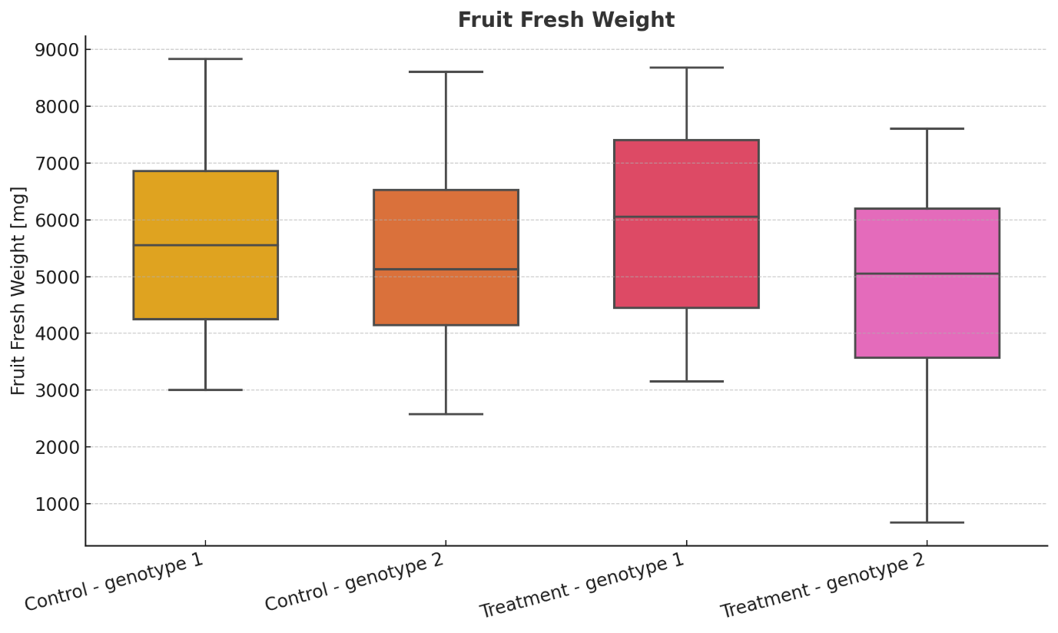
Graph 2: Boxplot of average fruit weight for the four different tests carried out.
3.5 BRIX DEGREE
The Brix degree, which measures the soluble sugar content, is a key indicator of fruit quality. In this experiment, the Brix degree was measured for fruits harvested from both lighting conditions. As reported in Table 4, control plants produced fruits with a Brix value of 6.1, while fruits from the treated plants reached a slightly higher value of 6.3. Although the numerical difference between the two groups is minimal, this slight increase may suggest a marginal improvement in sugar accumulation associated with the presence of far-red light.
Nevertheless, given the limited difference in Brix degree as well as the small sample size, it is necessary to expand the data collection. The observed variation falls within the range of natural variability commonly reported for strawberries.
Table 4: Only fruits from genotype 1 were tested for brix degree.
 | Control (°B) | Treatment (°B)
Genotype 1 | 6.1 | 6.3
3.6 CDE
Using the indicators described so far and by combining them with literature data to convert the Brix degree into g of sugar over ml of solution [44], assuming the water and soluble sugars content to be around 92% [47], and considering the fruit set to occur in the 60 % of flowers [46] we calculated the CDE value for the two tested genotypes under the two different growing conditions, as detailed in section 2.3.
As reported in Table 5, values vary significantly among the four alternatives, suggesting the importance of both genotype and growing conditions on their value.
This indicator has the capability of describing several aspects of food production on an extraterrestrial basis, as it considers the calories produced over a particular time and for a specific system in terms of power needs. For the calorie computation, we rely on both quality indicators (Brix degree) and productivity indicators (number of flowers, fresh fruit weight). In contrast, the energy consumption is specific to a given system and is constant in this work. However, the CDE indicator may also serve to compare different systems.
Treated plants show a higher CDE, expressing their capability of providing more calories to the astronaut's diet in a given time span. This may be mainly due to the overall capability of producing a certain number of flowers rather than the time it takes to produce fruit, which is less relevant. Genotypes again play a pivotal role, as genotype 1 is more responsive to treatment, showing a threefold higher value of CDE. In contrast, genotype 2 is only 1.5 times more efficient in terms of CDE.
Table 5: Average value of computed calorie delivery efficiency (CDE)
 | Control (kcal/kW*day) | Treatment (kcal/kW*day)
Genotype 1 | 15.70 | 46.76
Genotype 2 | 19.93 | 30.10

4 - DISCUSSION AND CONCLUSIONS
In this work, we conducted an experiment involving the production of strawberries within an aeroponic system in an environmentally controlled greenhouse within the context of space farming. Two strawberry genotypes were tested based on their physiological responses to the addition of far-red radiation to a white broad-spectrum light. The present paper reports the construction of the autonomous greenhouse, the growing conditions of the plants, and the indicators selected for assessing both the productivity of the system and the quality of the product. Moreover, these indicators were computed to derive and calculate a new indicator, named calorie delivery efficiency (CDE), which is particularly useful for special farming applications. This indicator considers at once the calories (in this context derived from the sugar content of strawberries) produced by a given system (considering its energy requirements) over a certain period of time.
CDE is expressed in units of kcal over kW·day. Therefore, it measures the amount of edible energy produced relative to the energy consumed over time. Within a controlled environment of agriculture and space farming, where energy availability is limited, this indicator captures the direct relationship between biological output and technological input, making it easier to compare space food production systems in terms of their efficiency in providing food to astronauts. CDE is particularly valuable since, from a measurement theory standpoint, it qualifies as a ratio-scale variable according to Stevens’ typology. It means CDE calculation has zero information loss, enabling the complete application of statistical tools.
The reported result highlighted a strong effect of the light treatment on flowering time and flower number (which may be related to the length of the observation period). In contrast, the time to the first fruit showed a weaker effect of the extra radiation. Additionally, far-red radiation had no effect on fruit weight or sugar content (assessed as Brix degrees). Moreover, the two different genotypes responded differently to the treatment, suggesting that the observed physiological response is tightly related to the tested cultivar.
Nevertheless, CDE (which accounts for both fruit weight, sugar content, and days to first fruit) showed a wide range of values, highlighting its capability to define system efficiency in calorie delivery. Interestingly, the genotype played a role as significant as the treatment, as genotype 1 scored three times more kcal per kW·day on the treated plants compared to the control, whereas genotype 2 only scored 1.5 times more kcal per kW·day.
These results need to be validated with a larger number of plants and light treatments. However, CDE has proven itself to be a valuable indicator for space-farming food production systems. Therefore, future work might involve different combinations of radiations (e.g. substitution and addition of extra radiations) as well as time-selective radiation addition.

ACKNOWLEDGEMENTS

This work was supported by the Agritech National Research Center and received funding from the European Union Next-GenerationEU (Piano nazionale di ripresa e resilienza (PNRR) – Missione 4 componente 2, investimenti 1.4 – D.D. 1032 17/06/2022, CN00000022) and PNRR – Decreto Ministeriale n. 1061. This manuscript reflects only the authors’ views and opinions, neither the European Union nor the European Commission can be considered responsible for them.

This study was carried out within the Space It Up project funded by the Italian Space Agency, ASI, and the Ministry of University and Research, MUR, under contract n. 2024-5-E.0 - CUP n. I53D24000060005.

We also thank Professor Bruno Mezzetti for providing the plant material and Professor Franco Capocasa for his inestimable suggestions regarding strawberry cultivation.

5 – REFERENCES
[1] F. B. House, A. Gruber, G. E. Hunt, and A. T. Mecherikunnel, “History of satellite missions and measurements of the Earth radiation budget (1957–1984),” Rev. Geophys., vol. 24, no. 2, pp. 357–377, 1986.
[2] J. Doran and P. Bizony, Starman: The truth behind the legend of Yuri Gagarin. A&C Black, 2011.
[3] D. M. Harland, The first men on the moon: the story of Apollo 11. Springer, 2007.
[4] M. J. Turner, Rocket and spacecraft propulsion: principles, practice and new developments. Springer Science & Business Media, 2008.
[5] T. Sahinkaya and S. Kim, “International space station resupply cost minimization,” presented at the IIE Annual Conference. Proceedings, Institute of Industrial and Systems Engineers (IISE), 2018, pp. 360–365.
[6] H. W. Jones, “Take Material to Space or Make It There?,” in ASCEND 2023, 2023, p. 4618.
[7] M. K. Ewert and C. Stromgren, “Astronaut Mass Balance for Long Duration Missions”.
[8] SpaceX, “SpaceX - capabilities & services.” [Online]. Available: https://www.spacex.com/humanspaceflight
[9] G. Mina, G. Peira, and A. Bonadonna, “Public perception and social sustainability of indoor farming technologies: A systematic review,” Technol. Soc., vol. 75, p. 102363, 2023.
[10] M. T. P. Nguyen et al., “Space farming: horticulture systems on spacecraft and outlook to planetary space exploration,” Plant Physiol. Biochem., vol. 194, pp. 708–721, 2023.
[11] N. Grasso, B. Fasciolo, A. M. M. Awouda, and G. Bruno, “A Smart Aeroponic Chamber: Structure and Architecture for an Efficient Production and Resource Management,” in Hydroponics: The Future of Sustainable Farming, Springer, 2024, pp. 353–380.
[12] V. Kumar, S. Singh, R. Jakhwal, B. Singh, and H. Tomar, “Space farming: Need for fresh vegetable crop,” Ann. Hortic., vol. 16, no. 1, pp. 65–71, 2023.
[13] Y. V. Tertyshnaya and N. Levina, “Effect of light spectrum on crops growth,” Agric. Mach. Technol., no. 5, pp. 24–29, 2016.
[14] L. Marcelis, E. Goto, B. Grodzinski, S. Torre, J. Wargent, and B. Bugbee, Crop Physiology Under LED Lighting. Frontiers Media SA, 2022.
[15] M. Urrestarazu, C. Nájera, and M. del Mar Gea, “Effect of the spectral quality and intensity of light-emitting diodes on several horticultural crops,” HortScience, vol. 51, no. 3, pp. 268–271, 2016.
[16] M. Al Murad, K. Razi, B. R. Jeong, P. M. A. Samy, and S. Muneer, “Light emitting diodes (LEDs) as agricultural lighting: Impact and its potential on improving physiology, flowering, and secondary metabolites of crops,” Sustainability, vol. 13, no. 4, p. 1985, 2021.
[17] E. Appolloni et al., “Beyond vegetables: effects of indoor LED light on specialized metabolite biosynthesis in medicinal and aromatic plants, edible flowers, and microgreens,” J. Sci. Food Agric., vol. 102, no. 2, pp. 472–487, 2022.
[18] G. C. Modarelli, R. Paradiso, C. Arena, S. De Pascale, and M.-C. Van Labeke, “High light intensity from blue-red LEDs enhance photosynthetic performance, plant growth, and optical properties of red lettuce in controlled environment,” Horticulturae, vol. 8, no. 2, p. 114, 2022.
[19] G. Pennisi et al., “Optimal light intensity for sustainable water and energy use in indoor cultivation of lettuce and basil under red and blue LEDs,” Sci. Hortic., vol. 272, p. 109508, 2020.
[20] B. IuA, “Choice of plant light status for space greenhouse: results of ground-based experience,” Aviakosmicheskaia Ekol. Meditsina Aerosp. Environ. Med., vol. 34, no. 1, pp. 38–44, 2000.
[21] R. C. Morrow, “LED lighting in horticulture,” HortScience, vol. 43, no. 7, pp. 1947–1950, 2008.
[22] E. Schettini, “Lighting equipment for a crop growing system in microgravity conditions for space mission,” presented at the International Conference on Sustainable Greenhouse Systems-Greensys2004 691, 2004, pp. 217–224.
[23] M. Mickens et al., “A strategic approach for investigating light recipes for ‘Outredgeous’ red romaine lettuce using white and monochromatic LEDs,” Life Sci. Space Res., vol. 19, pp. 53–62, 2018.
[24] E. Vitale et al., “Light quality modulates photosynthesis and antioxidant properties of B. vulgaris L. plants from seeds irradiated with high-energy heavy ions: implications for cultivation in space,” Plants, vol. 11, no. 14, p. 1816, 2022.
[25] E. J. Kennebeck and Q. Meng, “Mustard ‘Amara’Benefits from Superelevated CO2 While Adapting to Far-red Light Over Time,” HortScience, vol. 59, no. 2, pp. 139–145, 2024.
[26] Nicolò Grasso and Franco Lombardi, “Key Performance Indicators for Space Farming: A Framework from Literature.”
[27] Open Source Software, Mycodo Environmental Monitoring and Regulation System. [Unix/Linux]. Available: https://kizniche.github.io/Mycodo/
[28] O. Deschambault, A. Gherbi, and C. Légaré, “Efficient Implementation of the MQTT Protocol for Embedded Systems.,” J. Inf. Process. Syst., vol. 13, no. 1, 2017.
[29] C. Pascual, I. Agulto, A. Espino, and V. Malamug, “Effect of ground heat exchanger for root-zone cooling on the growth and yield of aeroponically-grown strawberry plant under tropical greenhouse condition,” presented at the IOP Conference Series: Earth and Environmental Science, IOP Publishing, 2019, p. 012006.
[30] S. Y. Wang and M. J. Camp, “Temperatures after bloom affect plant growth and fruit quality of strawberry,” Sci. Hortic., vol. 85, no. 3, pp. 183–199, 2000.
[31] Y. Lu, M. Gong, J. Li, and J. Ma, “Optimizing controlled environmental agriculture for strawberry cultivation using RL-Informer Model,” Agronomy, vol. 13, no. 8, p. 2057, 2023.
[32] O. M. Heide, “Photoperiod and temperature interactions in growth and flowering of strawberry,” Physiol. Plant., vol. 40, no. 1, pp. 21–26, 1977.
[33] T. M. K. Mohamed, J. Gao, M. E. Abuarab, M. Kassem, E. Wasef, and W. El-Ssawy, “Applying different magnetic water densities as irrigation for aeroponically and hydroponically grown strawberries,” Agriculture, vol. 12, no. 6, p. 819, 2022.
[34] P. Lieten, “The effect of humidity on the performance of greenhouse grown strawberry,” presented at the IV International Strawberry Symposium 567, 2000, pp. 479–482.
[35] J. Zheng, D. He, and F. Ji, “Effects of light intensity and photoperiod on runner plant propagation of hydroponic strawberry transplants under LED lighting,” Int. J. Agric. Biol. Eng., vol. 12, no. 6, pp. 26–31, 2019.
[36] Y. Li, J. Xiao, G. Guo, and B. R. Jeong, “Transplant pre-chilling induces earlier flowering and fruiting for forcing-cultured June-bearing strawberries,” Sci. Hortic., vol. 288, p. 110371, 2021.
[37] Y. Park, R. Sethi, and S. Temnyk, “Growth, flowering, and fruit production of strawberry ‘Albion’in response to photoperiod and photosynthetic photon flux density of sole-source lighting,” Plants, vol. 12, no. 4, p. 731, 2023.
[38] S. Hokanson and F. Takeda, “Strawberry fruit and plug plant production in the greenhouse,” presented at the XXVI International Horticultural Congress: Berry Crop Breeding, Production and Utilization for a New Century 626, 2002, pp. 283–285.
[39] N. Ünal and V. Okatan, “Effects of drought stress treatment on phytochemical contents of strawberry varieties,” Sci. Hortic., vol. 316, p. 112013, 2023.
[40] M. Nakayama and Y. Nakazawa, “Effects of environmental control and LED supplemental lighting on strawberry growth and yield in a subtropical climate,” Sci. Hortic., vol. 321, p. 112349, 2023.
[41] P. B. N. Bolivar et al., “IoT—Based Aeroponic System for Seasonal Plants Using Fuzzy Logic,” presented at the TENCON 2022-2022 IEEE Region 10 Conference (TENCON), IEEE, 2022, pp. 1–6.
[42] U. El-Behairy, A. Abou-Hadid, M. Medany, and S. Ahmed, “Effect of side and level of cultivation on production and quality of strawberry produced by aeroponic system,” presented at the International Symposium on The Horizons of Using Organic Matter and Substrates in Horticulture 608, 2002, pp. 43–51.
[43] R. Rivero, A. Sønsteby, O. M. Heide, K. A. Solhaug, and S. F. Remberg, “Growth analysis of the everbearing strawberry ‘Delizzimo’under controlled temperature and photoperiod conditions,” CABI Agric. Biosci., vol. 3, no. 1, p. 43, 2022.
[44] H. Kallio, M. Hakala, A.-M. Pelkkikangas, and A. Lapveteläinen, “Sugars and acids of strawberry varieties,” Eur. Food Res. Technol., vol. 212, pp. 81–85, 2000.
[45] D. Southgate and J. Durnin, “Calorie conversion factors. An experimental reassessment of the factors used in the calculation of the energy value of human diets,” Br. J. Nutr., vol. 24, no. 2, pp. 517–535, 1970.
[46] A. Gudowska, A. Cwajna, E. Marjańska, and D. Moroń, “Pollinators enhance the production of a superior strawberry–A global review and meta-analysis,” Agric. Ecosyst. Environ., vol. 362, p. 108815, 2024.
[47] R. Raj, A. Cosgun, and D. Kulić, “Strawberry water content estimation and ripeness classification using hyperspectral sensing,” Agronomy, vol. 12, no. 2, p. 425, 2022.

