Cost Cutting by using Regression based models for Predictive Analysis of Gas Generator Temperature using the Chamber Pressure as predictors in the Liquid Rocket Engine
Priya Esther DR^{1*},Harikumar B², Jobel Ratnam ^{3,} , Chandrasekharan C ⁴ of ISRO Propulsion Complex, Mahendragiri.
¹Sci/Engr SE,PTS -I
²DH,ETID
³Group Head ETIG
⁴Deputy Director, AISE, of IPRC Mahendragiri, ISRO.

* priyaesther@iprc.gov.in
ABSTRACT
The Liquid engine testing is carried out in three phases. The development testing, the acceptance tests and the qualification testing. Considering the lineage of the testing of certain Liquid Engines in India, it is proposed to use AI/ML tools of MATLAB to predict the test Engine parameters using Regression models.
The Test Article (The Human Rated Liquid Engine) measurement system comprises of Process Measurements namely Pressure, Temperature, Strain, Speed, and Vibration. Erstwhile Test Article measurement system used individual Signal Conditioning Amplifiers, Excitation Power supplies, and an Integrated Data Acquisition system acquires the test data at 2000 Samples per second was inducted to replace the old PXI based data acquisition systems. The induction of the IDAS was pivotal in ensuring accurate and precise measurements required in the Human Rated Liquid Engine ground testing.
The major parameters of the Test article are used for evaluating the various regression models and a few are selected for the predictive analysis. This paper elucidates on various models used to predict the Turbine Gas temperature in correlation with the Chamber Pressure of a High Thrust Liquid Propulsion Engine.
The future scope of the paper is creating tested models for various Injectors of the High Thrust Liquid Propulsion Engine so that cost cutting can be ensured by doing away with the qualification hot tests for Injector acceptance.
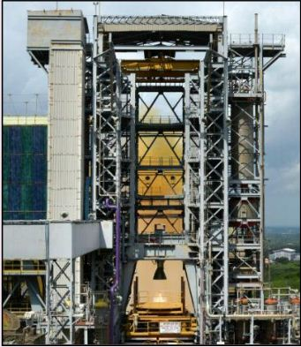
Keywords: Regression, Predictive Analysis, Rocket Engine Parameters.
NOMENCLATURE
MR | Mixer Ratio
IDAS | Integrated Data Acquisition System
RMSE | Root Mean Square Error.
GPR | Gaussian Process Regression.

INTRODUCTION
As a part of the Acceptance testing of Injectors of the Liquid Engines, Hot tests are carried out at the Principal Test Stand Facility. Considering the huge test measurements data base, many prediction models were developed, trained and tested using different sets of test data.
This paper elucidates the various models, compares the models and predicts the test data of the Engine Gas turbine Temperature.
Similar models can be developed, deployed for various parameters of the Rocket Engine like temperature, Strain, vibration etc.

Fig (i) The Liquid Engine Hot Test in the Human Space Flight program.

LITERATURE REVIEW AND OBJECTIVE
Predictive data analytics is the art of building and using models that make predictions based on patterns extracted from historical data. The Injector acceptance testing happens in a series , example HTI 6.1,6.2, 6.3 etc. In the paper being discussed , a model is developed using one of the tests in the test series and using the developed model, the data of another test is predicted.
This paper elucidates various models that were used predict the data of the various test parameters of the Liquid Propulsion Engines.
The objective of the model development is to predict the data of various test parameters of the Liquid Propulsion Engines. A key step in any predictive analytics project is deciding which type of predictive analytics model to use and hence various models were studied.

THE MOTIVATION BEHIND:
The costing incurred in conducting the Hot Test on any Liquid Propulsion Engines is quite phenomenal. The model generated paves way for predictive analysis of the Liquid Propulsion Engines.
The results of the predictive model were checked in-tandem with the Actual Hot Test Data and the same were validated and found to be accurate.
Develop ML algorithms for Predictive Analysis of Rocket Engine Parameters

Test the Tools with the previous Hot Test Data.
Predict the Gas Turbine Temperature using the model developed. Compare the Predicted Gas Turbine Temperature model with the Actual Hot Test Data.

TEST ARTICLE MEASUREMENTAND DATA ACQUISITION SYSTEM

The Principal Test Stand being one of the Test Facilities of ISRO, the erstwhile Test article measurement system comprised of independent signal conditioning modules, separate excitation source and the data was acquired in the PXI system.
Human Rated Liquid Engine test requirements were critical and to ensure the required accuracy class, the state of art Integrated Data Acquisition System in which the sensor excitation, signal conditioning unit, and Data Acquisition System are incorporated into a single chassis was inducted and elaborate tests were carried out. The total channel capacity of the IDAS is 260 channels.

IDAS comprised of pressure, temperature, vibration, modules. The various modules of IDAS were synchronized by the proprietary IRIG-B synchronization scheme and were grounded to a separate Instrumentation ground system which is maintained at 1 ohm Ground resistance which is achieved by using special grounding Techniques.
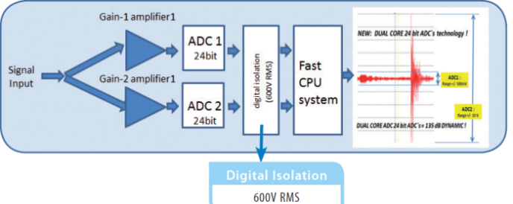

Fig (ii) The Dual Core ADC of the (IDAS)
DUAL CORE ADC technology (Fig ii) always gives the full possible measuring range, because the signal is measured with a high and a low gain at the same time. The data acquisition modules are isolated between themselves and the main board. The anti aliasing filter removes the noise in the signal.
The over voltage protection of 200 V is versatile in protecting the Data Acquisition system against accidental power supply shorts. The variable excitation and sense is versatile and any sensor like 21 NA or MIDAUS or IDLV can be used along with the module.

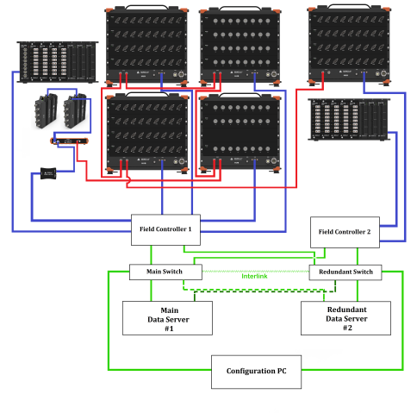

Fig (iii) The Integrated Data Acquisition System.

PRESSURE MEASUREMENT SYTEM.

Pressure measurement is crucial as it directly relates to performance of Engine and the Chamber Pressure is also an Abort parameter. Chamber pressure of engines is one of the critical measurement aspects, as it will be used to calculate thrust, analyze performance stability. In the Hot Tests for the Human Rated Liquid engine, 4 numbers of Chamber pressure measurements were taken to ensure the redundancy in the measurements.
The following figures show the chamber pressure plots of the 4 tests in which the margin variation of the Chamber pressure and the mixture ratio were varied.
Two out of four hot tests were conducted with +4% increased mixture ratio(MR) (1.768% ) and two tests were conducted with -4% variation (1.632%). The Chamber Pressure was also varied by +2% and -2%. The Engine performance was normal and the values of the dynamic Pressure was also within the limits of <0.5 bar.
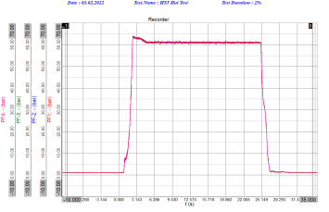
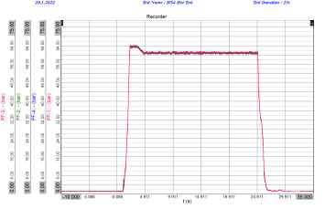

Fig (v) HS5 Chamber Pressure
Fig (iv) HS4 Chamber Pressure

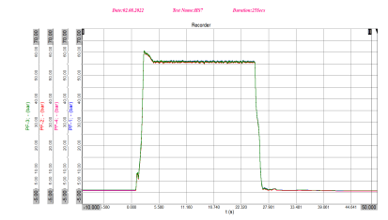
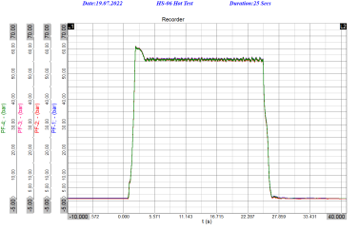

Fig (vii) HS7 Chamber Pressure
Fig (vi) HS6 Chamber Pressure

TEMPERATURE MEASUREMENT SYSTEM.
The Temperature across various parts of the engine namely the Thrust Chamber, Throat, Gas generator, etc are measured using K type thermocouple and the Integrated Data Acquisition system used for acquiring the data at 100 Samples per second.
The IDAS temperature Module has a real time controller and has additional add-on feature of storing the Data in the module.
The throat back wall Temperature TCH3A,B, C, TCH4A,B, C and TCH 5A,B,C measurements are critical in ascertaining the health of the throat. In the event of gas entry because of throat peel off, a sudden raise in the Temperatures 3A, 4A and 5 A will be observed.
Similarly Temperatures in the Gas Generator (GG) namely Gas Generator Inlet Temperature and Gas Generator Outlet Temperature are crucial parameters and also are abort parameters. In the Human Rated Engines, the redundancy of the measurements.
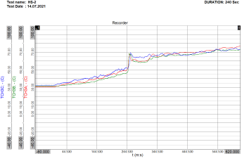
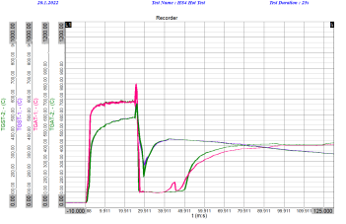

Fig (ix) The Temperature plot for Long duration Test of 240 seconds
Fig (viii) The Gas Generator Temperatures

THE REGRESSION MODELS DEVELOPED.
Regression models were developed using the Chamber Pressures , PF1 ,PF2,PF3 as predictors and the Gas Generator Temperatures TGAT1 was the response parameter.
The various models developed are
- Decision Trees
  - Fine Tree
  - Course Tree
  - Medium Tree
  - Ensemble Tree
  - Bagged Tree
- Exponential GPR.
- Optimizable Ensemble

FUTURE SCOPE OF WORK
In line with the predictive modeling carried out for the correlation between the Chamber Pressure and the Turbine Gas Generator Temperature, various other models for the correlation between the temperature of the Engine Divergent Nozzle , Strain , and other major parameters can be worked on.
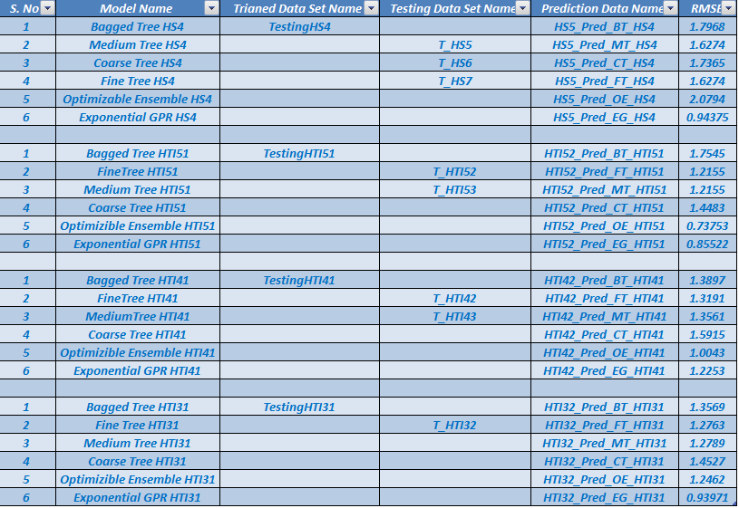
8 CONCLUSION.

The Above table elucidates the various models developed and the Root mean square error for the various models developed.
Off the developed models, the Exponential GPR models and Optimizable Ensemble models have the least Root means Square error in the order of 0.73753.

\

ACKNOWLEDGEMENTS
The Authors sincerely thank the Management of IPRC for providing the relevant infrastructure of the state of the art Integrated Data Acquisition system , and a GPU server

REFERENCES
[1]Report On Test And Evaluation Of Integrated Data Acquisition System (IDAS) For PTS Instrumentation
[2] PXI-Based Architecture for Real-Time Data
Acquisition and Distributed Dynamic Data
Processing. E. Barrera, M. Ruiz, S. López, D. Machón, and J. Vega
[3] Low Cost Ground Test Equipment for Atmospheric
Rocket Flights Using Embedded Systems.O. O. Babayomi, C. A. Osheku, M. A. L. Adetoro, A. Okon, and A. O. Opasina
Centre for Space Transport and Propulsion, Epe, Lagos
National Space Research and Development Agency (NASRDA)
Federal Ministry of Science and Technology, FCT, Abuja, Nigeria
Email: babayomi@ieee.org
[4] DAQ: Software Architecture for Data Acquisition in
Sounding Rockets.Mohammad Ahmad, Thanh Tran, Heidi Nichols, Jessica N. Bowles-Martinez
Jet Propulsion Laboratory, California Institute of Technology
Pasadena, CA 91009
818-458-0709 mohammad.ahmad@jpl.nasa.gov
[5] Overview of Combustion Instabilities in Liquid Rocket
Engines - Coupling Mechanisms & Control Techniques.John W. Bennewitz∗ and Robert A. Frederick†
University of Alabama-Huntsville Propulsion Research Center, Huntsville, AL, 35899.
[6] Gaussian Processes for Machine Learning .Author: Gerard Martínez Canelles.
[7] Applied Linear Regression by Sanford Weisberg.
[8] Gaussian Processes for Machine Learning
C. E. Rasmussen & C. K. I. Williams, Gaussian Processes for Machine Learning, the MIT Press, 2006, ISBN 026218253X.
[9]Performance Report On Human rated Liquid Engine Off-nominal Hs (4, 5, 6, 7) TestGY-IPRC-HRLV-L110-TR-091-22;R0
[10] Multivariate regression trees for analysis of abundance data - PubMed
[11] Development Of A Low Cost Data Acquisition System For The Space Shuttle Solid Rocket Booster Program David Pinkleton, Reusable Space Systems, Boeing North American Inc., Huntsville, Alabama.
[12] Liquid Propellant Rocket Engines , George P Sutton.
[13] Sivaramkrishnan Nair, K., Thomas, R. P., and Mahesh, G., "High Performance Liquid Engine," Recent Advances in Aerospace Sciences and Engineering, Proceedings of the International Symposium, Vol. 2, Interline Publishing, Bangalore, India, 1993.
[14] Lutz, O., "A Historical Review of Developments in Propellants and Materials for RocketEngines," First Steps Toward Space, American Astronautical Society History Series, edited by F. C. Durant, and G. S. James, Vol. 6, Univelt, Inc., San Diego, CA, 1985, pp. 103-112..
[15]Launch Vehicles and Their Propulsion," Jane's Space Directory, 12th and 16th eds., Jane's Information Group Limited, Coulsdon, Surrey, England U.K., 1996-1997, 2000-2001.
[16] Fundamentals of Machine Learning for Predictive Data Analysis. John D Kelleher.
[17] https://people.duke.edu/~rnau/compare.htm
[18] Gaussian Processes for Machine Learning ,C. E. Rasmussen & C. K. I. Williams,
[19] MATHWORKS -Documentation on Regression Trees, Hyper parameters, Gaussian Process Regression Models

Predict HS5 Using the Model HS4 – Fine Tree

The model developed: Actual Vs Predicted of HS4
Predicted Vs Actual of the model of HS4

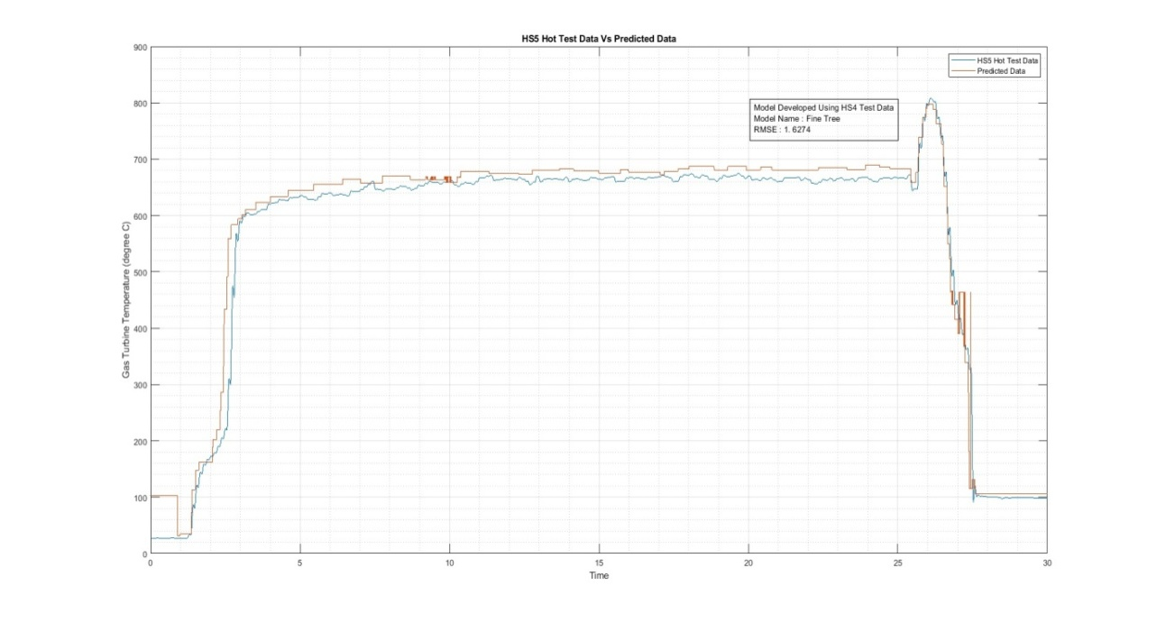
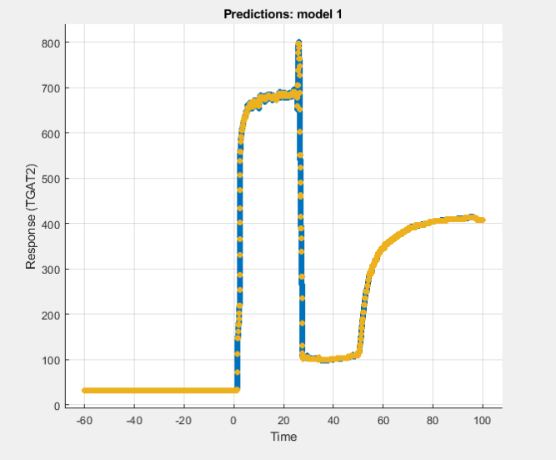
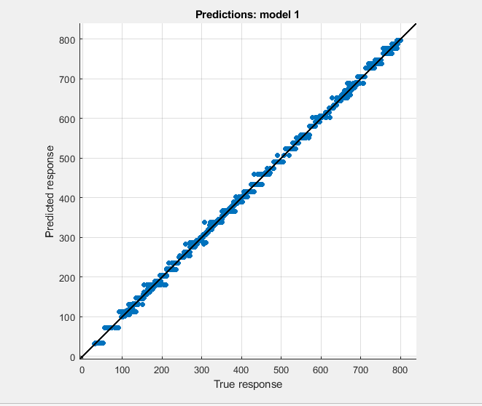
Model Name: Fine Tree
RMSE: 1.6274
R Squared: 1
MSE: 2.6484
MAE: 0.87094

The Plot of the Predicted Data with the Actual Hot Test Data of HS5
Predict HS5 Using the Model HS4 – Medium Tree

The model developed: Actual Vs Predicted of HS4
Predicted Vs Actual of the model of HS4

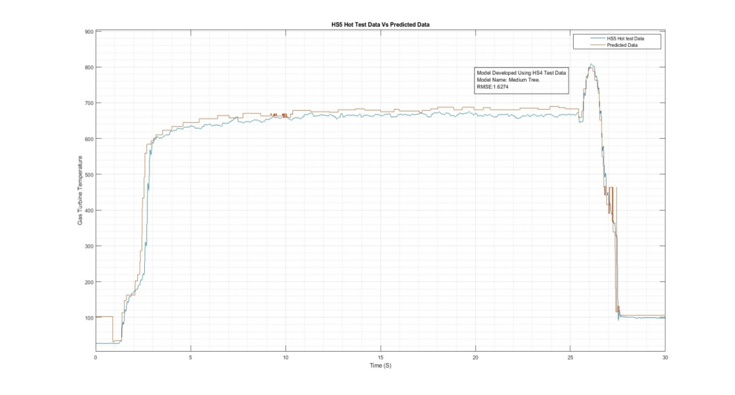
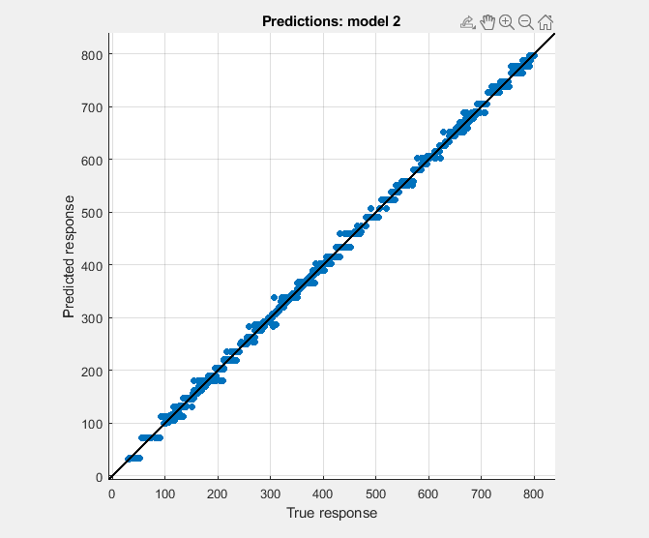
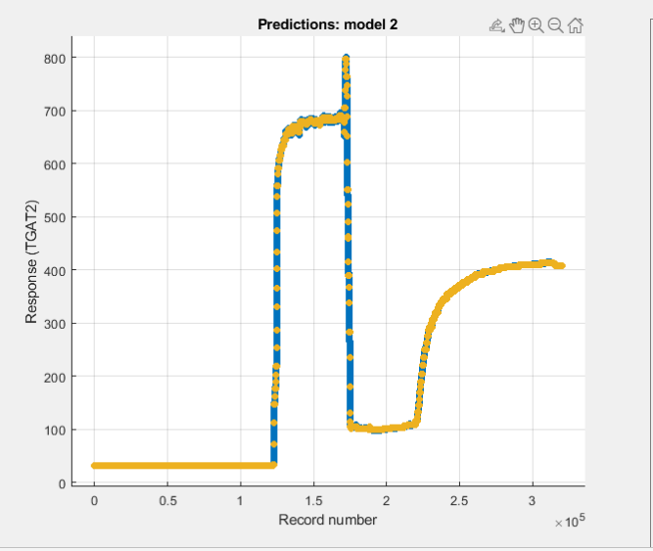
Model Name: Medium Tree
RMSE: 1.6274
R Squared: 1
MSE: 2.6484
MAE: 0.87094

The Plot of the Predicted Data with the Actual Hot Test Data of HS5
Predict HS5 Using the Model HS4 – Coarse Tree
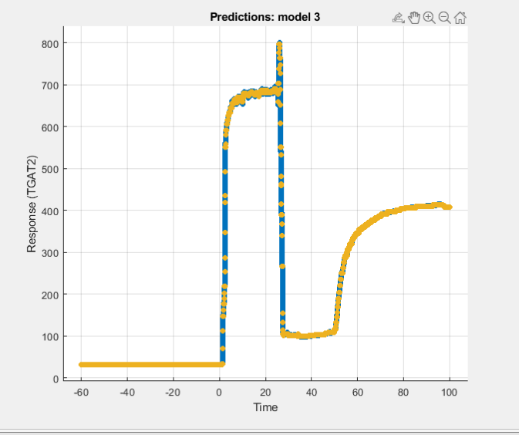
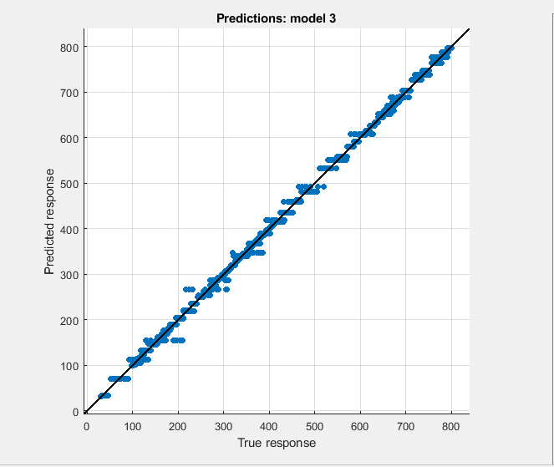
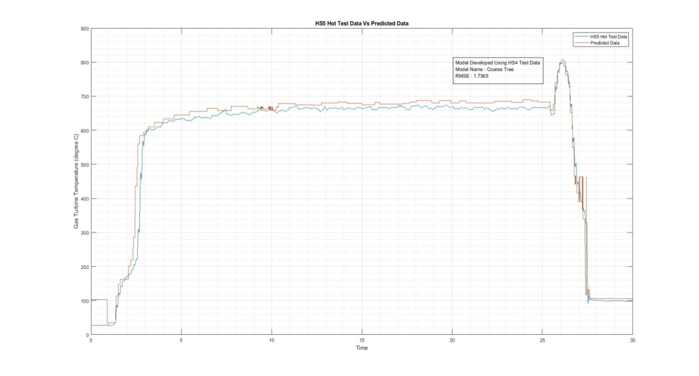
The model developed: Actual Vs Predicted of HS4
The Plot of the Predicted Data with the Actual Hot Test Data of HS5
Model Name: Coarse Tree
RMSE: 1.7365
R Squared: 1
MSE: 3.0153
MAE: 0.8795

Predicted Vs Actual of the model of HS4
Predict HS5 Using the Model HS4 – Bagged Tree

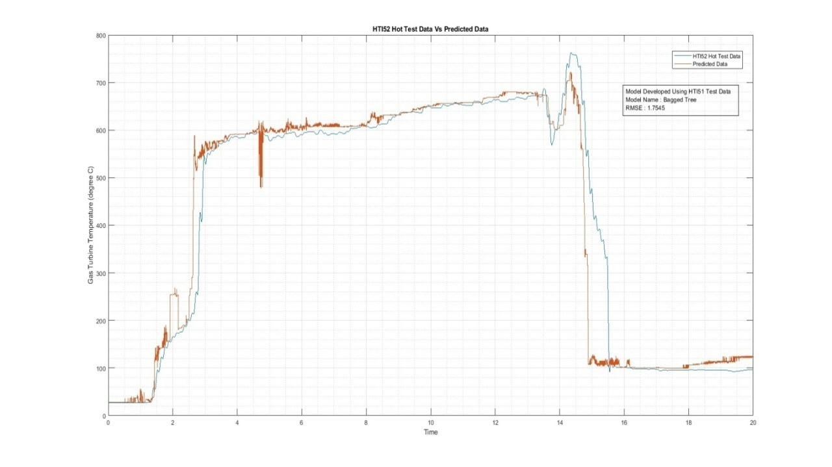
The Plot of the Predicted Data with the Actual Hot Test Data of HTI52
Predicted Vs Actual of the model of HTI51
The model developed: Actual Vs Predicted of HTI51
Model Name: Bagged Tree
RMSE: 0.81185
R Squared: 1
MSE: 0.6591
MAE: 0.37237

Predict HTI52 Using the Model HTI51 – Optimizable Ensemble

Predicted Vs Actual of the model of HTI51

The model developed: Actual Vs Predicted of HTI51

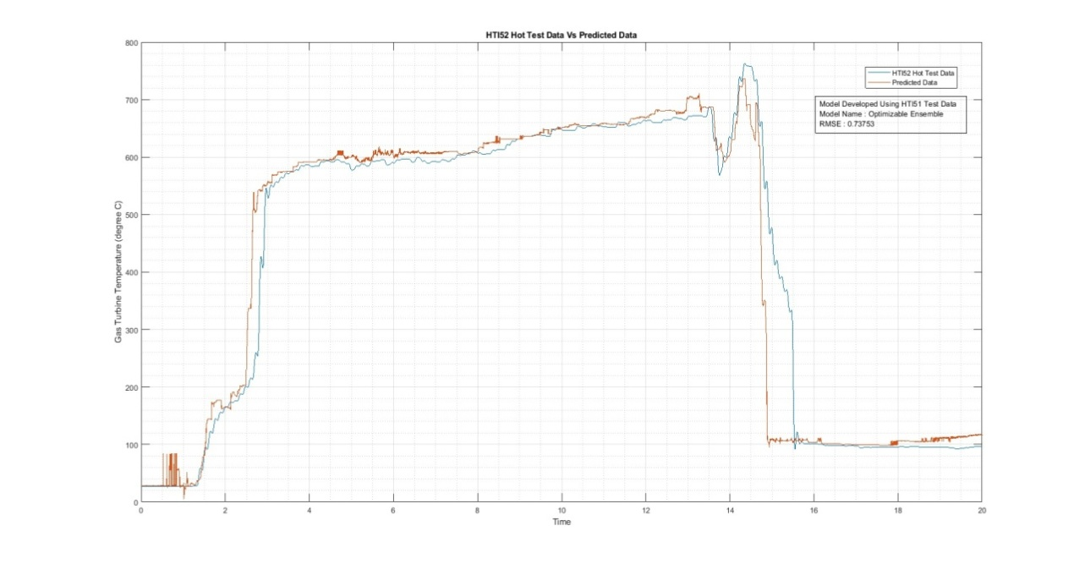
Model Name: Optimisable Ensemble
RMSE: 4.5797
R Squared: 1
MSE: 20.973
MAE: 1.7387

The Plot of the Predicted Data with the Actual Hot Test Data of HTI52
Predict HTI52 Using the Model HTI51 – Exponential GPR

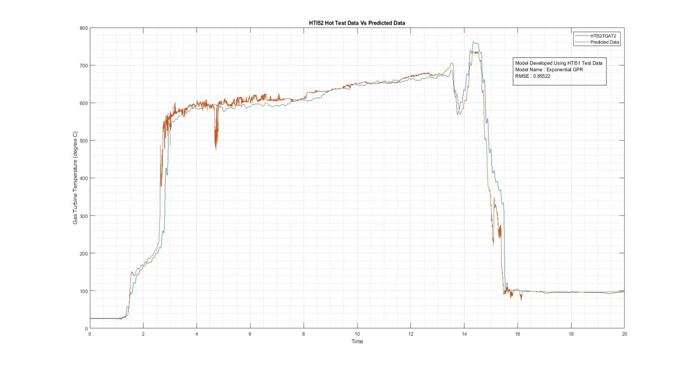
Model Name: Exponential GPR
RMSE: 0.85522
R Squared: 1
MSE: 0.7314
MAE: 0.080191

The Plot of the Predicted Data with the Actual Hot Test Data of HTI52
Predicted Vs Actual of the model of HTI51
The model developed: Actual Vs Predicted of HTI51

