PDC2025
Stellenbosch, Cape Town, South Africa

☐ Earth Impact Effects & Consequences

New evaluation of the morphology of the Kalkkop Crater, South Africa

Matthew S. Huber ⁽¹⁾⁽²⁾, Francois Fourie⁽³⁾, Kelly Kirsten⁽⁴⁾⁽⁵⁾⁽⁶⁾, Jan van der Walt⁽⁷⁾ and Robyn Pickering⁽⁵⁾⁽⁶⁾
⁽¹⁾ Planetary Science Institute, Tucson, AZ, 85719-2395, USA ⁽²⁾ University of KwaZulu Natal, Durban, 54001, South Africa ⁽³⁾ Institute of Groundwater Studies, University of the Free State, Bloemfontein, 9300, South Africa ⁽⁴⁾ School of Energy, Construction and Environment, Coventry University, Coventry, United Kingdom ⁽⁵⁾ Department of Geological Sciences, University of Cape Town, Rondebosch, South Africa ⁽⁶⁾ Human Evolution Research Institute (HERI), University of Cape Town, Rondebosch, South Africa ⁽⁷⁾ Geo Electrical Consulting (GEC), 92 Rauch Avenue, Georgeville, Pretoria, South Africa

Keywords: Impact Crater, Terraced Crater, Small Impacts, Geophysics

The Kalkkop Crater, located in the Eastern Cape, South Africa, is a deeply eroded small impact structure that was filled with lake sediments following the impact event and formed at approximately 250 ka [1]. The crater was initially drilled for petrophysical studies [2], then later re-investigated to confirm the impact hypothesis [3]. The crater was assumed to have a simple crater morphology, based mainly on the surface expression. In this study, we re-investigate the Kalkkop crater using a new, 89 m drill core taken from the center of the structure with the purpose of studying post-impact lake sediments, as well as remote sensing for multispectral analysis of the impact site, drone images to generate a high-resolution digital elevation model (DEM), and geophysical techniques, including electrical resistivity tomography (ERT) and audio magnetotelluric (AMT) techniques to image the subsurface. We have identified previously unreported surface morphological features that define the outer boundaries of the lake sediments and the outer areas of structural deformation related to the impact event. The geophysical results show a zone of low resistivity extending to the lowermost portions of the imaged subsurface. Below the outer extent of the lake sediments, the subsurface transitions to a complex zone that extends to a depth of approximately 80 m below the surface, likely corresponding to listric faults. We interpret the results as reflecting a terraced morphology (e.g., “inverted sombrero”) rather than a simple crater morphology (Figure 1). The crater infill is consistent with protracted sedimentation overlying impact-generated breccia. Previous work had assumed that the crater floor was encountered at depth, but our new results suggest that the drill cores were in fact passing through large blocks within the fallback ejecta. The diameter of the Kalkkop crater was previously reported as 600 m in diameter, but based on our new results, the crater has a maximum diameter of 1600 m. The Kalkkop Crater has implications for the consequences of impacts into layered target rocks in terms of crater formation and post-impact processes.

References
[1] Koeberl C., Reimold W.U., Shirey S., and Le Roux F. 1994. Kalkkop Crater, Cape Province, South Africa: Confirmation of impact origin using osmium isotope systematics, Geochimica et Cosmochimica Acta, Vol. 58, 1229-1234. [2] Blignault J., Rossouw P., De Villiers J., and Russell H. 1948. The Geology of the Schoorsteenberg Area, Cape Province. Geological Survey of South Africa, Explanation of Sheet No. 166. Pretoria, South Africa. [3] Reimold W.U., Le Roux F., Koeberl C. and Shirey, S. B. 1993. Kalkkop crater, Eastern Cape-A new impact crater in South Africa. Lunar and Planetary Science XXIV, 1197- 1198.

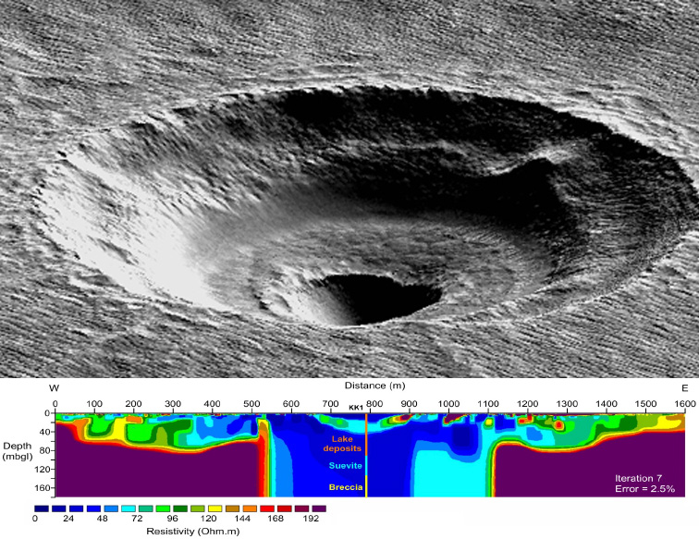
Figure 1: The terraced crater in the Arcadia Planitia region of Mars compared to the ERT results of this study. The profile through the middle of the crater reflects the interpretations given by [3] based on drill core analysis. The crater is best explained as a terraced morphology.

**************************************

Comments:

This abstract is relevant to terrestrial impact processes and would be best given as an oral presentation.

