PDC2025
Stellenbosch, Cape Town, South Africa

☐ Deflection / Disruption Modeling & Testing

Simulating Asteroid Deflection and Disruption Using an X-Ray Energy Deposition Model in SPH

Isaiah B. Santistevan⁽¹⁾, Mary T. Burkey⁽¹⁾, J. Michael Owen⁽¹⁾, and Kathryn M. Kumamoto⁽¹⁾
⁽¹⁾Lawrence Livermore National Laboratory, 7000 East Ave, Livermore, CA, 94550, USA, +1 925-422-1100

Keywords: Nuclear mitigation modeling, deflection, disruption, hydrocode

Asteroid impacts are serious natural disasters that may result in regional to global damage depending on the object’s mass and incoming velocity. However, with adequate preparation time, we may be able to prevent impacts from happening. One such mitigation method is the “kinetic impactor” method, which involves deliberately impacting the asteroid threat with a spacecraft, as demonstrated by NASA’s Double Asteroid Redirection Test mission [1], [2]. For exceptionally massive asteroids or situations where there is insufficient time for a kinetic impactor to be effective, we could rely on nuclear mitigation methods to deflect or intentionally and robustly disrupt the object. In such scenarios, a nuclear explosive device (NED) can be detonated a distance away from the asteroid (the “height of burst” or HOB), producing a wealth of X-rays that heat and ablate the target’s surface. With sufficient energy, the ablated material will escape the asteroid’s gravitational pull, causing a change in the asteroid’s momentum, and subsequently, its orbit [3]. For cases in which accidental fragmentation from a deflection mission is possible, or if there is not enough time to execute a deflection mission, we could robustly disrupt the asteroid into many small, fast-moving fragments that pose no threat to Earth by using an NED with larger yield at a smaller HOB.

Currently, a common guideline for assessing intentional disruption events is whether the asteroid is deflected at a velocity exceeding 10 times the escape velocity. Whether this heuristic holds for nuclear mitigation methods has yet to be comprehensively tested. High-fidelity nuclear disruption simulations can be used to fill this knowledge gap and are thus crucial for well-informed mitigation mission design. We use the smoothed particle hydrodynamics (SPH) code Spheral to generate 3D simulations of asteroids and initialize them with an X-ray energy deposition model to simulate the effects of a nuclear device [4]. The left panel of Figure 1 shows the initial specific thermal energy deposited by the X-ray energy deposition model for a Bennu-shaped asteroid where lighter shades of green indicate larger initial energy values. Preliminary data from our Spheral simulations show broad agreement with previous deflection results in [4].

We present an exploration of robust disruption results for both Bennu-shaped and Itokawa-shaped asteroids scaled down to a diameter of 150 m. The right panel of Figure 1 illustrates a potential disruption event for a Bennu-shaped asteroid approximately 65 ms after the NED first illuminates the surface. The material is color-coded by velocity magnitude, with lighter shades representing higher velocities. By modeling and analyzing disruption simulations, we will help to define the regime in which robust disruption is a viable option compared to deflection missions, ultimately contributing to the development of effective planetary defense strategies.

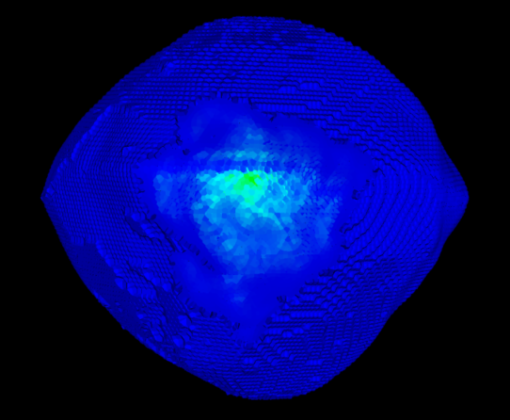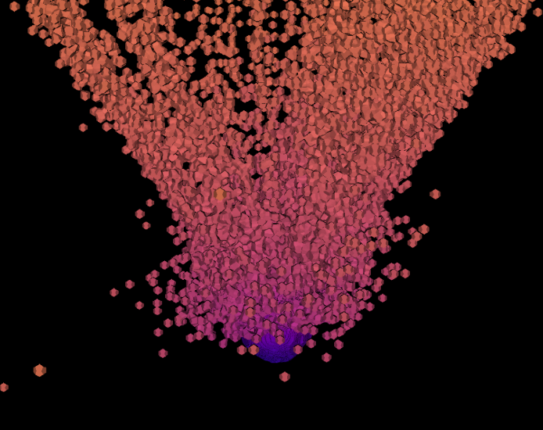
Figure 1. Left: A Bennu-shaped asteroid in Spheral, showing the specific thermal energy after initialized with the X-ray energy deposition model from [4]. Right: The Bennu-shaped asteroid approximately 65 ms after the energy deposition, where material is rapidly blown-off from the surface (color-coded by velocity magnitude).

Prepared by LLNL under Contract DE-AC52-07NA27344.
LLNL-ABS-871345

[1] R. T. Daly et al., "Successful kinetic impact into an asteroid for planetary defence," Nature, vol. 616, no. 7957, pp. 443-447, Apr 2023, doi: 10.1038/s41586-023-05810-5.
[2] A. F. Cheng et al., "Momentum transfer from the DART mission kinetic impact on asteroid Dimorphos," Nature, vol. 616, no. 7957, pp. 457-460, Apr 2023, doi: 10.1038/s41586-023-05878-z.
[3] D. P. S. Dearborn and P. L. Miller, "Defending Against Asteroids and Comets," in Handbook of Cosmic Hazards and Planetary Defense. Cham: Springer International Publishing, 2015, pp. 733-754.
[4] M. T. Burkey, R. A. Managan, N. A. Gentile, M. B. Syal, K. M. Howley, and J. V. Wasem, "X-Ray Energy Deposition Model for Simulating Asteroid Response to a Nuclear Planetary Defense Mitigation Mission," The Planetary Science Journal, 2023.

**************************************

Comments:

Oral session preferred

