PDC2025
Stellenbosch, Cape Town, South Africa

Please submit your abstract at https://iaaspace.org/pdc.

(please select the topic that best fits your abstract from the list below)
(you may also add a general comment - see end of this document)

☐ Ongoing and Upcoming Mission Highlights
☐ Apophis: T-4 Years
☐ Hypothetical Asteroid Threat Exercise
☐ Key International and Policy Developments
☐ Near-Earth Object (NEO) Discovery
☐ NEO Characterization
☐ Deflection / Disruption Modeling & Testing
☐ Space Mission & Campaign Design
☐ Earth Impact Effects & Consequences
☐ Disaster Management & Impact Response
☐ Public Education and Communication
☐ The Decision to Act: Political, Legal, Social, and Economic Aspects

LOSSOL: Line of Sight Speed of Light Directed Energy Technologies for Planetary Defense

Madhu Thangavelu
Department of Astronautical Engineering, Viterbi School of Engineering, Olin Hall of Engineering and the School of Architecture, Watt Hall,
University of Southern California, University Park,
Los Angeles, California, 90089-1191 USA, 310 561 2890
mthangav@usc.edu

Keywords: Directed Energy, High Energy Lasers, Joint Earth-Moon Defense Infrastructure(JEDI), Q-Bolt, DE-STAR, READI Project, International Space University

Introduction: Many strategies have been proposed for planetary defense. Most of them deal with long period intervention proposals that range from months to years and even decades to prepare and execute. While most strategies in the literature focus on very large potentially hazardous objects, especially those massive Earth crossing asteroids within our solar system with diameters larger than 1km, the probability of such an event is deemed very rare. Surveys have identified most such objects and a network of observatories including emerging space assets continue to track and refine their orbital trajectories. From recent observations, we know that much smaller objects with dimensions that are 10-20m across are far more common, and much harder to detect in a timely manner for a variety of reasons including paucity of observation and detection assets. Such objects, though small, can cause serious damage to critical physical infrastructure or if they happen to impact or airburst over populated regions. As populations expand over the globe and infrastructures like the intercontinental power grid global communication networks and other utilities become shared assets among nations, the threat of such an impactor causing havoc cannot be ignored.
Short Warning Period Threat: While new and more sensitive observatories are being commissioned and proposed to observe and detect such a threat, such small objects continue to impact our planet with little or no warning. Such a threat with little warning and time to prepare before impact is called short warning period threat. Several short warning impactor events have been recorded in the past decade and have even hurt populations and caused citywide damage. It is only recently that attention has turned toward mitigation of short warning period threat posed by extraterrestrial impactors.
Nuclear Option Not Viable: From past simulations and exercises conducted for Planetary Defense, it is clear that such an endeavor poses extremely sensitive policy issues, both domestic and global in nature. Therefore planning and strategies for mitigation have to be carefully analyzed and programmed in parallel with any suitable technology for successful mitigation. Nuclear detonation at close range may not be an option and poses thorny policy issues. Nuclear devices may also be far too potent to engage a small body, not to mention, the mission planning preparation, coordination and execution may not be viable for a short period warning response campaign.
High Energy Phased Array Lasers: Directed energy systems including kinetic kill devices like existing missiles and high energy phased array lasers have been proposed. The latter technology has been scaling in recent years to be effective as a PD deterrent for small objects on a terminal trajectory with short warning period.
Evolution Of A Directed Energy PD For Diffusing Short Warning Period Threat: We present a concept for evolving a planetary defense capability using existing assets and slowly evolving the capability starting with a directed energy orbital debris
mitigation system. Line-of-sight mitigation at the speed of light(LOSSOL) has several advantages over other methods.

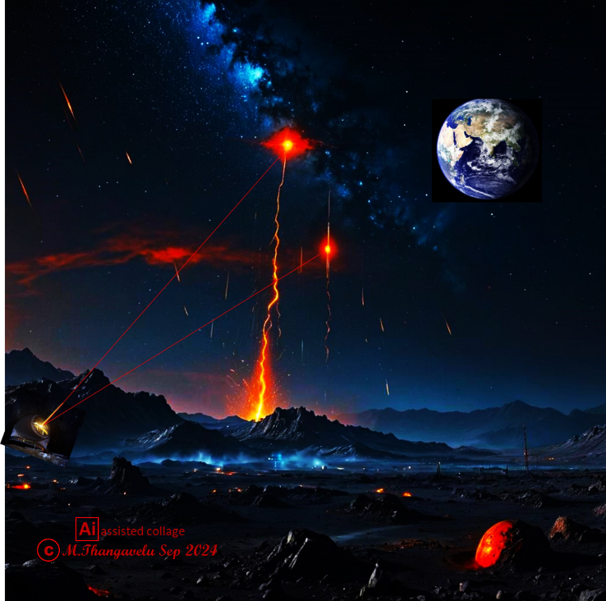

Figure1. Unlike the Earth, our Moon does not have an atmospheric blanket to protect exposed assets like observatories and habitats on the lunar surface from meteoritic and micrometeoritic impacts. Recent observations show the effects of constant bombardment on the lunar terrain. Systems commissioned for Planetary Defense on Earth can also be used for protecting high value assets on the surface of the Moon.[Figure1.]

Earth-Moon Applications: Unlike the Earth, our Moon does not have an atmospheric blanket to protect exposed assets like observatories and habitats on the lunar surface from meteoritic and micrometeoritic impacts. Recent observations show the effects of constant bombardment on the lunar terrain. Systems commissioned for Planetary Defense on Earth can also be used for protecting high value assets on the surface of the Moon.[Figure1.]
Conclusion: Once a reliable strategy based on directed energy can be evolved incrementally and implemented in a phased manner, systems developed and gradually deployed for removing orbital debris on a global scale, barring any mishaps, several associated technologies and operational procedures may be carried over, and mobile, modular systems ramped up in energy and agile deployment techniques adopted to evolve a short warning period planetary defense capability. Trust and Confidence Building Measures attained through gradual implementation via orbital debris mitigation is proposed as a potentially viable evolutionary Planetary Defense concept to investigate further.
This LOSSOL presentation will focus on current developments in high energy laser technology, merits and challenges, and Planetary Defense application of Directed Energy Systems for timely intervention of bolides threat to high value assets on the Moon and potential for Earh applications as well.

References
Lubin, P., Hughes, G. B., Bible, J. J., Bublitz, J., Arriola, J., Motta, C., ... & O’Neill, H. (2014). Toward directed energy planetary defense. Optical Engineering, 53(2), 025103-025103.
Lubin, P., & Hughes, G. B. (2015). Directed energy for planetary defense. Chapter in: Allahdadi, Firooz, and Pelton, Joseph N.(Eds.), Handbook of Cosmic Hazards and Planetary Defense, Springer Reference.
Burke, J. D., Hussain, A., Soni, A., Johnson-Freese, J., Faull, J., Schmidt, N., ... & Thangavelu, M. (2015, December). Roadmap for an EArth Defense Initiative (READI). In AGU Fall Meeting Abstracts (Vol. 2015, pp. NH11A-1901).
Hussein, A., Rozenheck, O., & Utrilla, C. M. E. (2016). From detection to deflection: Mitigation techniques for hidden global threats of natural space objects with short warning time. Acta Astronautica, 126, 488-496.
Melamed, N. (2013). Development of a handbook and an on-line tool on defending Earth against Potentially Hazardous Objects. Acta Astronautica, 90(1), 165-172.
"Nikola Schmidt, James Burke, Nahum Melamed, Madhu Thangavelu, Tomas Rousek."(2016).Extending Space Exploration By Evolving an Earth-Moon Planetary Defense Capability(2016)IAC-16,D3,1,2,x33552 International Astronautical Congress
Thangavelu, M., & Vasmate, V. (2016). LUNAR SENTINEL: Planetary Defense from the Moon. In AIAA SPACE 2016 (p. 5475).
Schmidt, N., & Thangavelu, M. (2017). Strengthening global collaboration and reducing the risk of defection of a cooperating nation in planetary defense. In 5th IAA Planetary Defense Conference—PDC 2017. Tokyo, Japan: International Academy of Astronautics.
Schmidt, N. (Ed.). (2018). Planetary defense: Global collaboration for defending earth from asteroids and comets. Springer.
Schmidt, N., Utrilla, C. M. E., Boháček, P., Silva-Martinez, J., & Worden, P. (2019). The Multipurpose Lunar Base as a First-Line Biosphere Defense and as a Gateway to the Universe. Planetary Defense: Global Collaboration for Defending Earth from Asteroids and Comets, 419-452.
Thangavelu, M. (2021). JEDI: The Joint Extraterrestrial Threats Defense Infrastructure-Evolving An Earth-Moon Planetary Defense Infrastructure. In ASCEND 2021 (p. 4112).
Thangavelu, Madhu. "USC CHASE II-Commercial Human Spaceflight Expeditions Part ll–Artemis Rising." In ASCEND 2023, p. 4608. 2023

Comments:
Please include me in an appropriate session, afternoon oral presentation preferred.

