PDC2025
Stellenbosch, Cape Town, South Africa

☐ Space Mission & Campaign Design

Novel Reutilization of the European Service Module in Service of Planetary Defense

Lorraine Fesq⁽¹⁾, Carol Raymond⁽¹⁾, Jennifer Scully⁽¹⁾, James Keane⁽¹⁾, Dave Bearden⁽¹⁾, Stephan Ulamec⁽²⁾, Jean-Baptiste Vincent⁽³⁾, Matthias Grott⁽³⁾, Christian J. Renggli⁽⁴⁾, Norbert Krupp⁽⁴⁾, Thorsten Kleine⁽⁴⁾, Matthias Winter⁽⁵⁾, Robert Luther⁽⁶⁾, Kai Wünnemann^{(6,7)}, and William Bottke⁽⁸⁾
⁽¹⁾ Jet Propulsion Laboratory/California Institute of Technology, 4800 Oak Grove
Drive, Pasadena, CA 91109
⁽²⁾ DLR, Linder Höhe, 51147 Köln, Germany
⁽³⁾ DLR Institute of Planetary Research, 12489 Berlin, Germany
⁽⁴⁾ Max Planck Institute for Solar System Research, Justus-von-Liebig-Weg 3, 37077 Göttingen,Germany
⁽⁵⁾ Airbus Defence and Space GmbH, Airbus-Allee 1, D–28199 Bremen, Germany
⁽⁶⁾ Museum für Naturkunde – Leibniz-Institute for Evolution and Biodiversity Science, Invalidenstraße 43, 10115 Berlin, Germany
⁽⁷⁾ Freie Universität Berlin, Institute of Geological Sciences, Planetary Sciences and Remote Sensing, Germany
⁽⁸⁾ Southwest Research Institute, Department of Space Studies, 1050 Walnut St, Suite 400, Boulder, CO 80302

Keywords: Small bodies, NEO access, repurpose

The lessons of reusing and repurposing mission assets are relevant to Planetary Defense and Small Body Science objectives, as expressed in the most recent decadal survey for Planetary Science and Astrobiology. As described in [1], the European Service Module (ESM), the element of NASA’s Artemis Program that returns the Orion Crew Module to Earth (Figure), currently is planned for destruction by burning up in the Earth’s atmosphere. However, the ESM is a capable spacecraft, complete with propulsion, attitude control, power generation/conditioning/distribution, thermal control, and payload support. By leveraging the remaining propulsive capabilities, post separation, it has the potential to provide a near term method, on a yearly cadence, at a reduced cost, for achieving science return across an array of mission types.

JPL hosted a scientific workshop in summer 2024, with US and European participants, to discuss potential ESM extended mission targets. The participants jointly assessed the benefits that could be derived from repurposing the ESM for scientific use after completing its primary mission. The participants generated over thirty concepts that offered significant value in areas such as planetary defense, planetary science, the exploration of Near-Earth Objects (NEOs), and cosmology. For example, there are many unexplored classes of near-Earth and main belt asteroids that could be reached with the ESM after its primary mission. Some of these bodies are associated with water (e.g., 24 Themis), others with metals (e.g., 216 Kleopatra), and others imply impact hazards. The ESM, in principle, can tour several diverse asteroids and possibly carry a small NEO sample return spacecraft [2], rapidly accelerating our understanding of these worlds. Another concept highlighted the capability to use the ESM as a large kinetic impactor, sending it to impact a suitable NEO. ESM has a dry mass seven times larger than the spacecraft used on the successful DART mission.

The ESM currently relies on the Crew Module for several functions including communications, computing, and attitude control sensors; thus, several spacecraft functions would need to be added. Also, ESM mass margins would allow accommodation of a scientific payload, opening the possibility to expand the prime mission for additional science objectives. The concepts considered were divided into augmentation categories of no augmentation (impactors), minimal augmentation (flybys), and low-to-moderate augmentation (orbiters, landers).

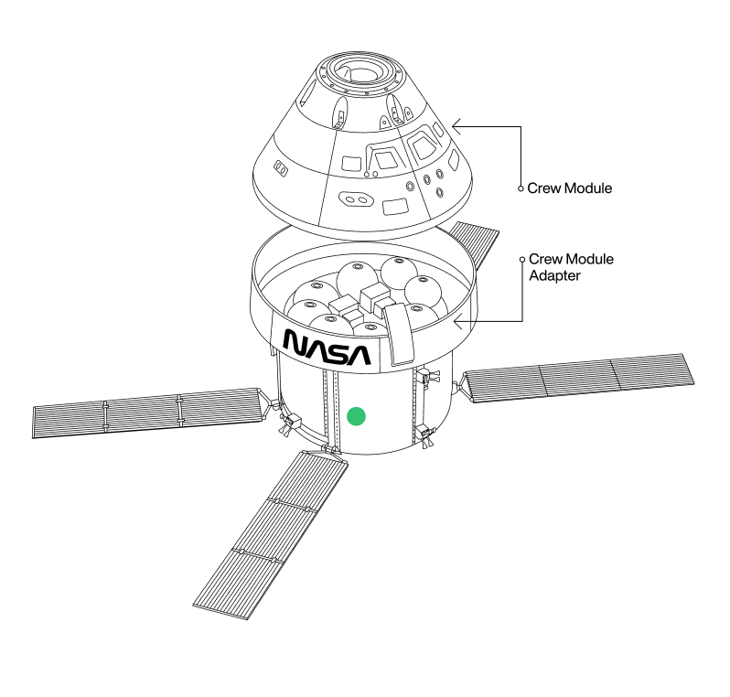
ESM
Figure. The ESM will have propulsive capabilities post Crew Module separation that offer a near-term, low-cost method to achieve high leverage science goals across an array of mission types.

The highest priority for each ESM mission is to accomplish the primary mission objectives within the Artemis program. Although the ESM has the potential to deliver additional scientific value beyond its current scope, the scientific value added will have to be weighed against programmatic considerations and carefully analyzed within the ESM's programmatic framework and its stakeholders. Acknowledging this, we explore the possibilities to achieve tantalizing science objectives at a lower-cost.

Acknowledgement: The research was carried out at the Jet Propulsion Laboratory, California Institute of Technology, under a contract with the National Aeronautics and Space Administration (80NM0018D0004).

References:
[1] Freeman, A., Fesq, L., Matousek, S., Karimi, R., Zimmermann, R., Steckling, M., Winter, M., “Low-Cost Mission Architectures to Small Bodies,” IAA-PDC-23-09-20, Acta Astronautica, Volume 224, 2024, Pages 122-126, ISSN 0094-5765, https://doi.org/10.1016/j.actaastro.2024.08.014.

[2] Hilchenbach, M., Kleine, T., Grundmann, J. T., APOSSUM team, “Grabbing a sample from a real Near-Earth Asteroid: A very fast Sample Return Mission opportunity” Abstract submitted to PDC2025, 2025.

