9th IAA Planetary Defense Conference – PDC 2025
5-9 May 2025, Stellenbosch, Cape Town, South Africa

IAA-PDC-25-XX-YY-presentation.pdf

PULSAR KINETIC IMPACT TECHNOLOGIES & DESIGN

Author: Thomas A. Harris
Interplanetary Kinetic Impactor Technologies and
Space Research Institute/Last Chance Planetary Defense.
16948 Melville Rd SE Tenino, WA 98589,
United States
Phone: (509) 855-0070
Email:lastchanceplanetarydefense@gmail.com

The leading notion in the scientific community today is still the same as when Bong Wei and Brent Barbee presented their abstract at the 2013 Planetary Defense Conference titled “Conceptual Design of a Flight Validation Mission for a Hypervelocity Asteroid Intercept Vehicle”. https://ntrs.nasa.gov/api/citations/20130011729/downloads/20130011729.pdf.
That in order to protect Earth from a extinction level NEO humanity would have to deploy nuclear weapons into to space. That being the Hyper Velocity Asteroid Intercept Vehicle which low and behold to this very day is still the only option that NASA has in the two of them that have been built by NASA. That being because of the impact crater technology deployed which creates a shallow crater before the NED then enters the crater and detonates.
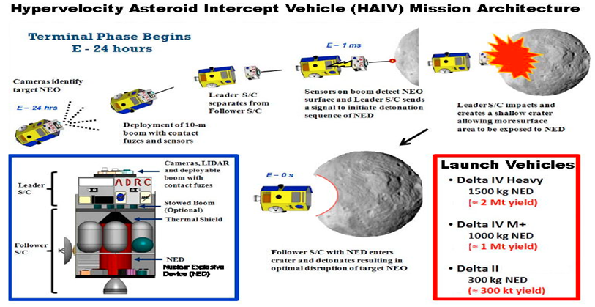
The effects of creating a crater before detonating in that crater are said to increase the effectiveness of the nuclear blast. Credit: https://www.space.com/21333-asteroid-nuke-spacecraft-mission.html
As explained in accompanying Abstract and Scientific Paper what once Brent Barbee and Bong Wie concluded would be the best choice to defend our planet has gotten even better. With the advent of the Fusion Rocket came a new ability not previously available at the time when Babree and Wie wrote their Abstract in 2013. Now we can take the same principles presented in the (HAIV) mission architecture and implement “Pulsar”.
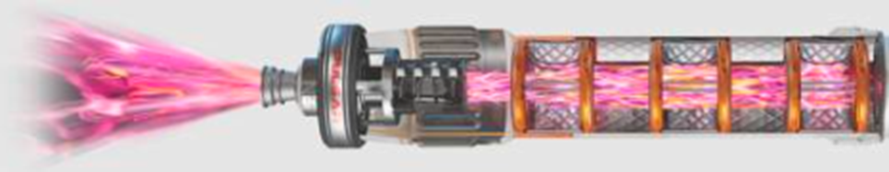
https://en.topwar.ru/221315-pulsar-fusion-i-princeton-satellite-systems-razrabotajut-termojadernyj-raketnyj-dvigatel.html
When introducing “Pulsar” to the (HAIV) concept we quickly see the benefits that’s “Pulsar” will offer. First the increase of speed and velocity due to the fact that “Pulsar” can reach a speed of 500,000 mph. With the increase of speed comes the increase of energy and effectiveness on impact. With Pulsar the Hyper Velocity Kinetic Impactor acts both as an impactor and nuclear explosion without the need actually deploy nuclear weapons. And thus eliminating the risk of a failed launch and nulcear detonation on the launch pad.
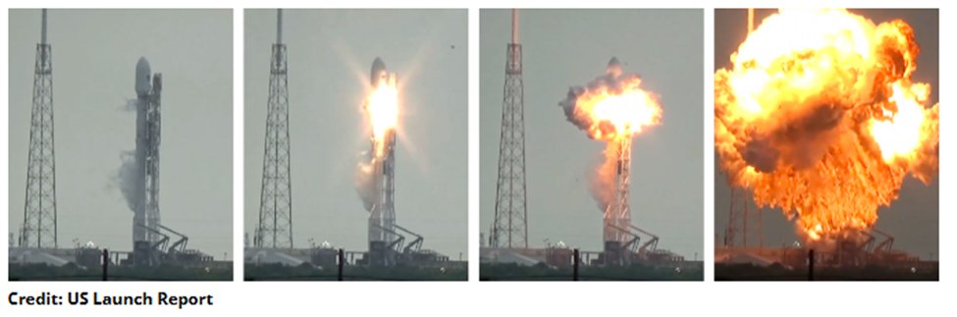
https://spaceflightnow.com/2016/09/01/spacex-rocket-and-israeli-satellite-destroyed-in-launch-pad-explosion/
Taking the two main concepts originally proposed by Barbree and Wie and increasing their effectiveness more than a 1000-fold. As explained in the accompanied Scientific Paper to this presentation: “To calculate the kinetic energy for both objects using their respective masses and velocities we will assume that the collision is frontal. In that way the two velocities add up and the total kinetic energy is KE = (1/2) (m1+m2) (v1+v2)2 . The result is KE = 9.99x1025 Joules. The KE of the asteroid dominates however the effect of the force from the massive release of energy completely diverts the asteroid from its path to impact the Earth. One megaton is 4×1015. Thus, the KE in megatons is 2.5x1010 megatons = 2.5x107 Kilo-Tons = 1667 Hiros”. When in comparison to Barbee and Wie’s paper we see that with pulsar, although this calculation is assuming a 650,000lbs Hyper Velocity Kinetic Impactor that even with a mere 1000lbs Hyper Velocity Kinetic Impactor that the amount of engery released on impact with is contributed to its deflection is many gigatons vs 2 Megatons max as set forth in Barbee and Wie’s 2013 paper.
Supporting the implementation of Pulsar is the most recent “DART” Mission which proved that a small spacecraft could divert a small moon from its orbit.
“DART impacted the asteroid moonlet Dimorphos, a small body just 530 feet (160 meters) in diameter. It orbits a larger, 2,560-foot (780-meter) asteroid called Didymos”. Credit: NASA
“DART navigated to crash itself into Dimorphos at a speed of approximately 6.1 kilometers (3.8 miles) per second. The total mass of the DART spacecraft was approximately 1,345 pounds (610 kilograms) at launch and roughly 1280 pounds (580 kilograms) at impact”. Credit: https://dart.jhuapl.edu
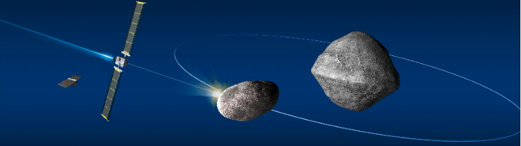
https://www.eoportal.org/satellite-missions/dart-asteroid

